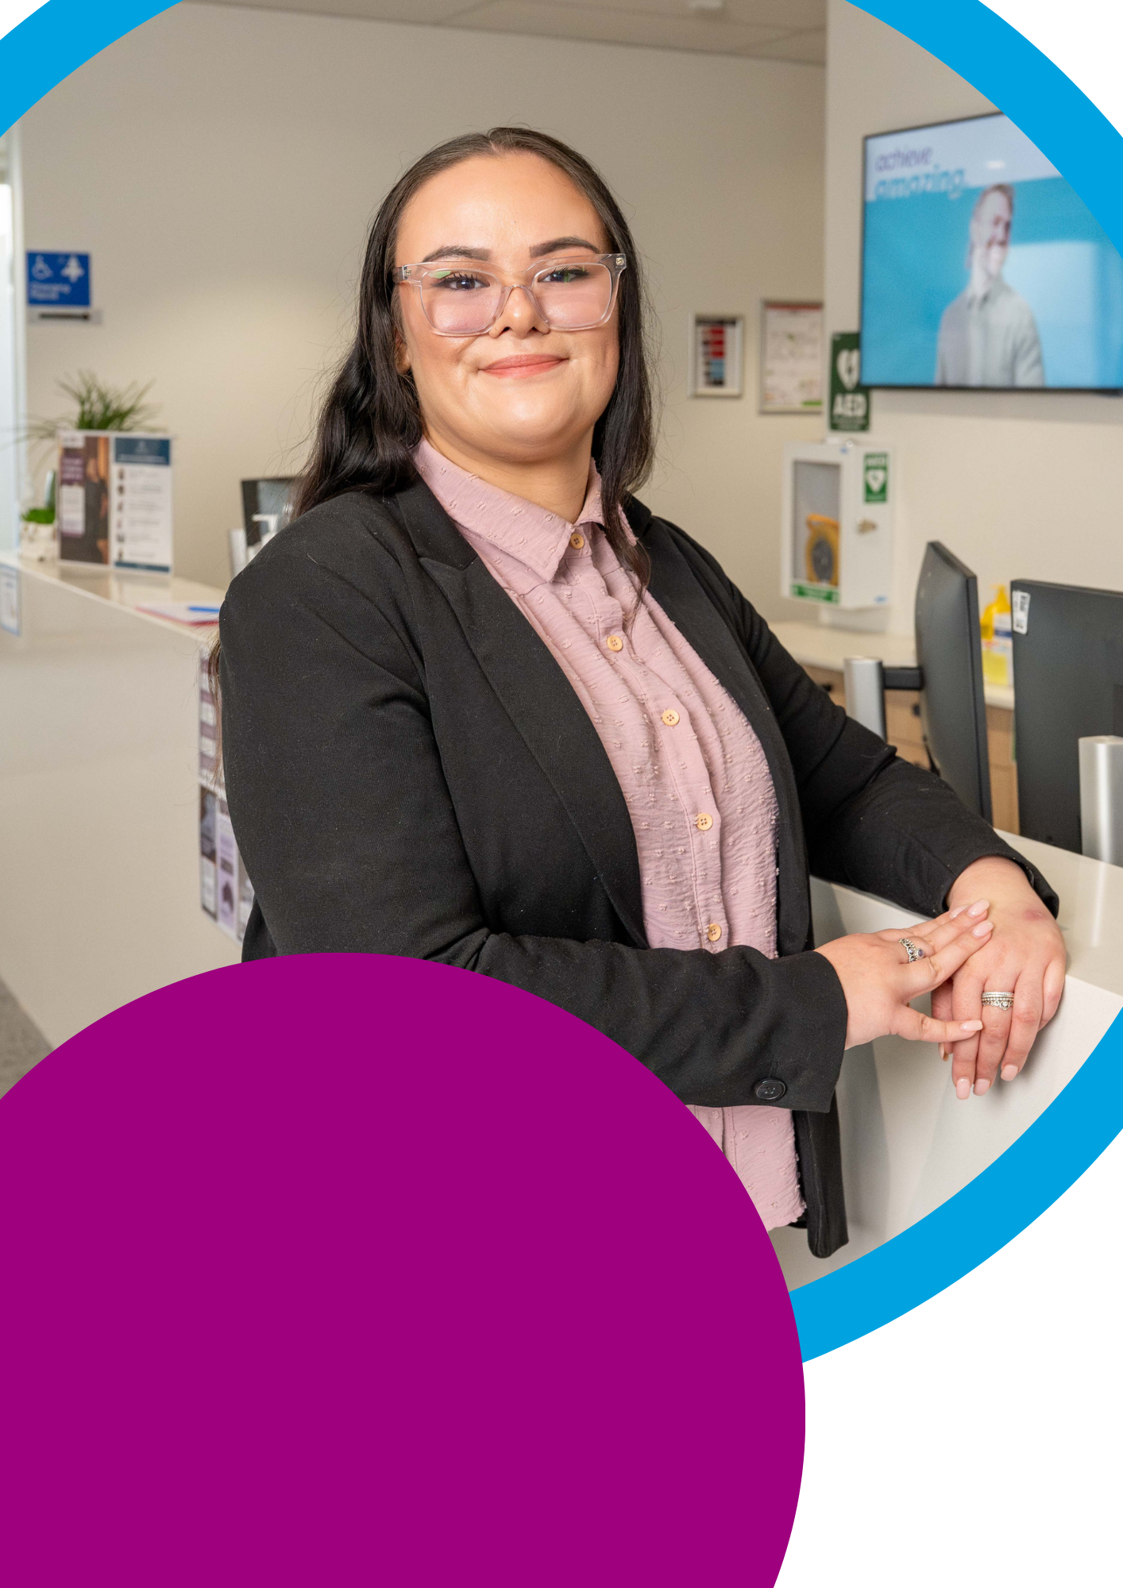

Career Progression for

People with Disability
A guide for employers.

jobaccess.gov.au 1800 464 800

Acknowledgement of Country
We acknowledge the traditional custodians of Australia and the lands upon which we live and work and pay our respects to Elders past and present.
We acknowledge the stories, traditions, and living cultures of Aboriginal and Torres Strait Islander peoples on this land, moving towards a shared direction of reconciliation to build a stronger future together.


Contents
Introduction 4
Dignified access 5
Funding support to improve accessibility in employment 6
What to keep in mind when discussing reasonable adjustments 7
Privacy 8
Unconscious bias 9
The role of decision makers 11
Promoting internal job opportunities 12
Interview and application support 13
Career progression avenues 14
Secondment 14
Mentoring 14
Job shadowing 16
Education and upskilling 17
Networking and team building 18
Leadership opportunities 20
Make it happen in your workplace 21

Introduction
There are close to 2.1 million people with disability of working age in Australia. However, the unemployment rate for people with disability is more than double that of those without disability. This gap hasn’t shifted in over two decades.
A key objective under the Australia’s Disability Strategy 2021-2031i is to move the dial on the disability employment gap and increase the employment rate of people with disability.
Research shows that people with disability are more productiveii, have a better safety recordiii, are more reliable, and are cost effectiveiv.
They have a wealth of skills, experiences, and qualifications that make them suitable for all kinds of jobs, including entry-level, middle management, and senior leadership positions.
Australian businesses are increasingly recognising the potential of people with disability. Their current focus lies on attracting new candidates by making recruitment and onboarding practices disability confident. However, in most cases, these efforts may not extend to training and career development opportunities.
The employment rate of people with disability is low, and so is their job satisfaction. Just over 50 per cent of employed people with disability are satisfied with their current job compared to more than 60 per cent of those without disability.
This dissatisfaction stems from the fact that only a few organisations have targeted career progression programs to support employees with disability. Just over one in five of Global DEI companies have such programs that are inclusive of people with disability. Fewer still (14 per cent) reported having advancement and retention programs specifically designed for employees with disability.v
A practical, barrier-free career development program can attract high-performing staff, retain valued employees, and increase overall motivation and productivity.
This guide provides suggestions to consider when creating or updating your organisation’s career development programs, using Australian and global research with good practice examples that can be adapted to support all employees who wish to progress their careers.
Alongside our own JobAccess experts, including those who live with disability, we interviewed leaders to understand more about career progression for people with disability. Our thanks to Sarah Hilt, Anaab Rooble and Daniel Gardner for generously sharing their experiences and advice.

Dignified access

Dignified access ensures independent and equitable access for people with disability

to any premises, goods and services.vi

Under Australia’s Disability Discrimination Act 1992, employers are expected to provide reasonable adjustments for people with disability required for dignified access and use of commercial premises.

Some examples of a reasonable adjustment could include:
- Adjustments to work arrangements for someone who needs breaks because of pain or fatigue
- Provision of a height adjustable desk for a person using a wheelchair
- Arranging telephone typewriter (TTY) access for a person who is Deaf or has difficulty speaking
- Screen reading software for employees who are blind or have low vision
- A customised chair or a stool designed to remove disability-specific barriers
- Change working hours to allow for the effects of medication
- Provision of e-learning or on-boarding processes in an accessible format



Funding support to improve accessibility in employment
Not everyone with disability requires an adjustment to perform their job. However, some may require one to perform the inherent requirements of their job.
The Employment Assistance Fund (EAF) gives financial help to eligible people with disability and mental health conditions, and employers, to buy work-related modifications, equipment, Auslan services, workplace assistance and support services.vii
It is available to people with disability who are about to start a job or who are currently working, and could help to buy work-related modifications and services like:
  - Adjustments or special equipment for a physical workplace
  - Modifications to work vehicles
  - Information and communication devices
  - Auslan interpreting
  - Specialist services for employees with specific learning disorders and mental health conditions
  - Disability or deafness awareness training
  - Mental health first aid training

Although costs associated with reasonable adjustments are minimal, often, employers invariably overestimate the likely cost of such adjustments. At the same time, many employees are unaware of the available support or are hesitant to ask for adjustments.
It's important to provide information and advice to hiring and frontline managers on cost- effective ways to accommodate team members. This can alleviate concerns about costs and reduce bias in performance evaluation.
Making small modifications to work routines or duties can enhance the performance of employees with disability, without incurring significant expenses.
Funding through the EAF does not cover ergonomic equipment. It is the responsibility of employers to make ergonomic adjustments for all employees.

What to keep in mind when discussing reasonable adjustments?
No two people will experience disability in the same way. It is highly recommended to take an individualised approach to support employees with disability in the organisation.

In the context of career development, consider the following:
- Check with an employee whether they require reasonable adjustments and make them available upon request
- Use Auslan interpreters where required
- Ensure your documents, such as guidelines, policies or processes, are available in an accessible format so they can be understood by people who use assistive technology, such as screen readers, braille devices and speech recognition systems. You can also offer easy to read versions for those with an intellectual disability
- Check your website or intranet for accessibility and measure against the Web Content Accessibility Guidelines (WCAG 2.2)
- Transfer any current reasonable adjustment/s to an employee’s new workstation
- Provide detailed information, such as a job analysis, to break-down requirements for roles when developing position descriptions
- Promote your organisation’s reasonable adjustment policy internally to all employees



Privacy

To encourage employees to be open with you about disability, reassure them that their information will be handled appropriately.
- To share the information about an employee’s disability with other people within your organisation (for example, staff in the human resources department or manager in a secondment opportunity), written consent must be obtained from the employee
- It is important to remember that you are required by law to respect the employee’s right to privacy. Failing to protect confidential personal information in relation to a person’s disability may in some circumstance involve, or lead to, discrimination
- Sometimes you may need to release private information if required by the law. The Office of the Privacy Commissioner has specific privacy information for employers, visit their website for further information (oaic.gov.au)viii

“Disability looks different for everyone who lives with disability and those who support people with disability. Leaders’ understanding of that is on the way to being much better than it used to be.
But there’s still a lot of work to do when understanding what disability looks like in your organisation.
Many organisations would be surprised, possibly, at the number of people who are already in their organisation, who either have disability or are supporting someone with disability, that they don’t know about.

The important thing is to take the time to understand the demographic of your people more clearly.
Once you know that, and the talent and skill set you already have, it’s vital that you then understand how you can support and reduce barriers for your current employees while also creating the environment to attract new employees.”

Sarah Hilt

Group Executive Personal Injury, MedHealth

Unconscious bias

Unconscious, implicit or hidden bias can be defined as a normal human prejudice about people or groups of people. It happens automatically and is triggered by making quick assessments of people and situations based on our own background, culture and personal experiences.
The human brain can process 11 million bits of information every second. But our conscious minds can handle only 40 to 50 bits of information a second. So, our brains sometimes take cognitive shortcuts that can lead to unconscious or implicit bias, with consequences for how we perceive and act toward other people.ix
Often people refer to first impressions and intuitions about others, which are ways of expressing unconscious bias. Unconscious bias is considered to be outside our control, though we can take steps to mitigate its effects.x

Unconscious biases are:
- Attitudes beyond our regular perceptions of ourselves and others
- Reinforced by our environment and experiences
- Basis that form a great deal of our patterns of behaviour about diversity



Impacts of unconscious bias

Unconscious bias in the workplace can mean:
- Talented people are left out of your workforce, or not allowed equal opportunity for development and career progression
- Diverse voices aren’t heard in meetings and decisions can be impaired
- Employees are not able to fully contribute to your organisation
- Creativity and productivity of your team or organisation may be compromised

It has been suggested that when people with disability are in applicant pools, hiring managers might incorrectly assume that these applicants do not want challenging careers or assignments.xi These biases impact decisions in all phases of the employment cycle.
Understanding our subconscious and unconscious bias is key to mitigating its impact.
This awareness helps us question assumptions and manage bias in personal and business decision-making both holistically and systemically. By acknowledging and addressing these biases, we can make more informed and fair-minded choices and processes that benefit everyone involved.


“We have aspirations and interest as anyone else but lack of tailored professional development, inaccessible workplaces, and barriers to career progression holds us back, not our aspirations!”

Anaab Rooble

Manager, Diversity and Inclusion,

Department of Families, Fairness and Housing President,

Victorian Public Sector Enablers Network

The role of decision makers
Employers must recognise that people with disability may have aspirations and career goals, just like any employee. It is recommended for organisations to ensure that employees with disability have the same opportunity as other employees to participate in career development programs.
The Center for Talent Innovation’s 2013 survey on Innovation, Diversity, and Market Growth found that employees with disability are more likely to share information about their disability at work when leaders foster inclusivity. Additionally, they are less likely to have their ideas ignored or feel stalled in their careers.xii
It is important that employers should not make career development decisions for an employee with disability based on limiting concepts or stereotypes about that employee’s disability.xiii
Supervisors should have the training to confidently discuss career expectations with each employee, including an evaluation of their interests, talents, and skills in relation to the requirements of available jobs. If an employee’s career goals seem unachievable, the
supervisor can provide constructive feedback and work with employees to set appropriate goals and paths to achieve them. However, the supervisor should not assume an employee’s disability will be a barrier.xiv
It is important to use inclusive language in education and career development programs that promote and encourage people with disability to apply to these opportunities. Equally
important is developing or maintaining an inclusive culture in your organisation, where those responsible for selecting employees make decisions based on merit rather than bias.

“Small steps lead to big changes. Australian businesses, today, are taking the right approach by focusing their efforts on removing any barriers in the recruitment and on-boarding process for people with disability.
However, they still lag behind when it comes to career advancement and leadership for employees with disability. This eventually creates a vacuum in productivity and leadership, where employees can feel stalled in their careers, and employers may lose their best talent.
It’s time for employers to improve their unconscious attitudes and beliefs and recognise that employees with disability also have aspirations and career goals.

And, just like others they must be given equal opportunities to participate in professional development and leadership training programs, which in turn help organisations to gain a competitive edge in the market.”

Daniel Valiente-Riedl

Former General Manager, JobAccess



Promoting internal job opportunities
As with external job advertisements, it is vital that new opportunities promoted within the organisation must be inclusive and apply good practice, to encourage interest from employees with diverse backgrounds and experiences.

What you can do:
- Include a diversity and inclusion statement to encourage employees with disability to apply for internal roles and participate in the selection process. As good practice, add reference to your company’s Reasonable Adjustment Policy in both internal and external job advertisements.
- Broaden your candidate pool by focusing on performance objectives. Rather than unnecessary requirements such as skills, experiences, degrees, and seniority levels, focus on performance objectives, i.e., what a person needs to be able to do and achieve in a position.
- Showcase that your organisation welcomes candidates who have the skills and are still learning and growing. Organisations that support their employees’ growth and offer opportunities for career advancement are more likely to attract diverse candidates.

Interview and application support

With lower turnover rates than their peers without disability, employees with disability may have less job interview experience or familiarity with current job application expectations than those who have had the opportunity to change roles regularly, gaining them additional exposure.
Organising professional development workshops can support employees with disability in gaining up-to-date advice for new opportunities.

What you can do:
- Provide interview skills training and/or practice sessions for current employees.
- Provide tip sheets or useful resources on how to complete a competitive application for roles within your organisation.
- Provide feedback in end-of-year performance reviews or reference letters to support employees in applying for senior, or different, roles within the organisation.


Career progression avenues

Secondment

Secondment refers to an opportunity for an employee to temporarily work in a different department and, in some instances, a different organisation. This allows the employee to gain additional exposure to a range of roles, to further develop their skills and improve their CV.
In addition, the employer benefits from the additional skills and experience when employees return to their original role. This often positively provides a fresh perspective on the organisation’s operations and adds to employee’s productivity as well.
A secondment can be an internal or external move. An internal secondment occurs within the same organisation, while an external secondment involves multiple organisations, often sister companies.
Secondment opportunities allow employees to become familiar with all aspects of a business, recognising the transferability of skills and abilities to other positions.
This experience can lead to job enrichment, providing more responsibilities and new assignments, which are important career development tools for people with disability.xv

Mentoring

Mentoring involves sharing knowledge and expertise by a more experienced

person ‘mentor’ to a less experienced person ‘mentee’.
The goal of mentoring is to assist mentees to acquire new skills and improve themselves through professional development, to advance their career.xvi
A workplace mentoring program:
- Promotes a culture which values learning and development, for both the mentor and mentee
- Supports personal and professional development
- Decreases stress and anxiety when faced with issues or concerns that may not be addressed by a manager, but with the guidance of a mentor

A well-structured and personalised mentoring program that is accessible and inclusive for all employees can increase the tenure of existing employees, who feel supported and confident that there is space and opportunity for them to develop within the organisation.

Mentors provide support by:
- Examining professional issues that may be impacting the mentee.
- Sharing new ideas and ways of thinking
- Advising on strategies to overcome weaknesses and developing strengths
- Developing short-term and long-term goals

Mentoring is a valuable learning experience for both mentors and employees with disability.
It erodes unconscious bias, broadens perspectives, facilitates the exchange of ideas and opens opportunities for diverse thought, experience, and innovation.
Mentoring opportunities not only benefit high-performing team members but can also enable low-performing employees to enhance their productivity with the right guidance, expert advice and support from their mentors.

“If employers are not focused on building career pathways for employees with disability, they are missing out on a large talent pool of innovative thinkers. Inclusive organisations for people with disability are well regarded by current and potential workers, and the broader community.


It’s not difficult, ensure workplace adjustments are extended to relevant career opportunities, such as learning and development, and higher duties. Leverage your systems (e.g., development plans) and programs (e.g., mentoring) already in place and make them work to develop people with disability.”
“

Daniel Gardner
Coordinator, Diversity and Inclusion, GOTAFE

Job shadowing

Australian businesses are constantly looking for ways to retain employees, foster worker development, and boost operational efficiency. One method that may help to accomplish these objectives is job shadowing.
A job shadowing program aims to broaden an employee’s knowledge and understanding of other roles, practices or systems within their current employer, or at another organisation.
Employees can closely observe and interact with experienced staff members and how they undertake their daily work activities. This can occur within a single business unit, or across multiple units involved in related roles or work processes.
A job shadowing can be part of a new staff member’s orientation, or existing staff members’ annual performance planning and career development programs.
Job shadowing programs offer invaluable opportunities to other areas of the business with increased exposure to employees with disability, reducing the impact of unconscious bias. Additionally, job shadowing can lead to the creation of a more diverse and inclusive workforce, break down myths and stereotypes and, most importantly, promote a more equitable workplace.
If an employee requires a reasonable adjustment, create a plan to implement specialised equipment so they can participate in short-term job shadowing opportunities.

Do you know about Australian Public Sector Commission’s (APSC) ‘Reasonable Adjustment Passport’?

The aim of the Passport is to ensure that any special needs and reasonable adjustments that an employee may have are documented. It ensures that when there is a change in manager or team lead, information about those adjustments is readily available.

The Passport allows the employee to explain in their own words their circumstances, their experience in the workplace and their specific needs to support them at work.

The Passport is a tool to have open discussions with their manager regarding any adjustments they may require, including access to part time and flexible working arrangements.

Education and upskilling

Acquiring new skills can help employees with disability succeed in their current role

and progress in their career.

To foster an organisation’s culture of learning and development, it is recommended that employers should support individuals who wish to pursue further education and skill development.
Employees may choose between professional courses, such as leadership or public speaking, or vocational training, like management courses. These options will lead to increased job satisfaction, morale, and performance improvement.
An additional benefit is that employees will be able to develop the essential skills and confidence to adjust to new processes, strategies, or technology within the organisation.
Through education, the employee may also be able to identify skill gaps and receive assistance from the organisation, to address these gaps.
Studies have also shown that there is a higher retention of employees who have recognised their employers as supporting their education.xvii

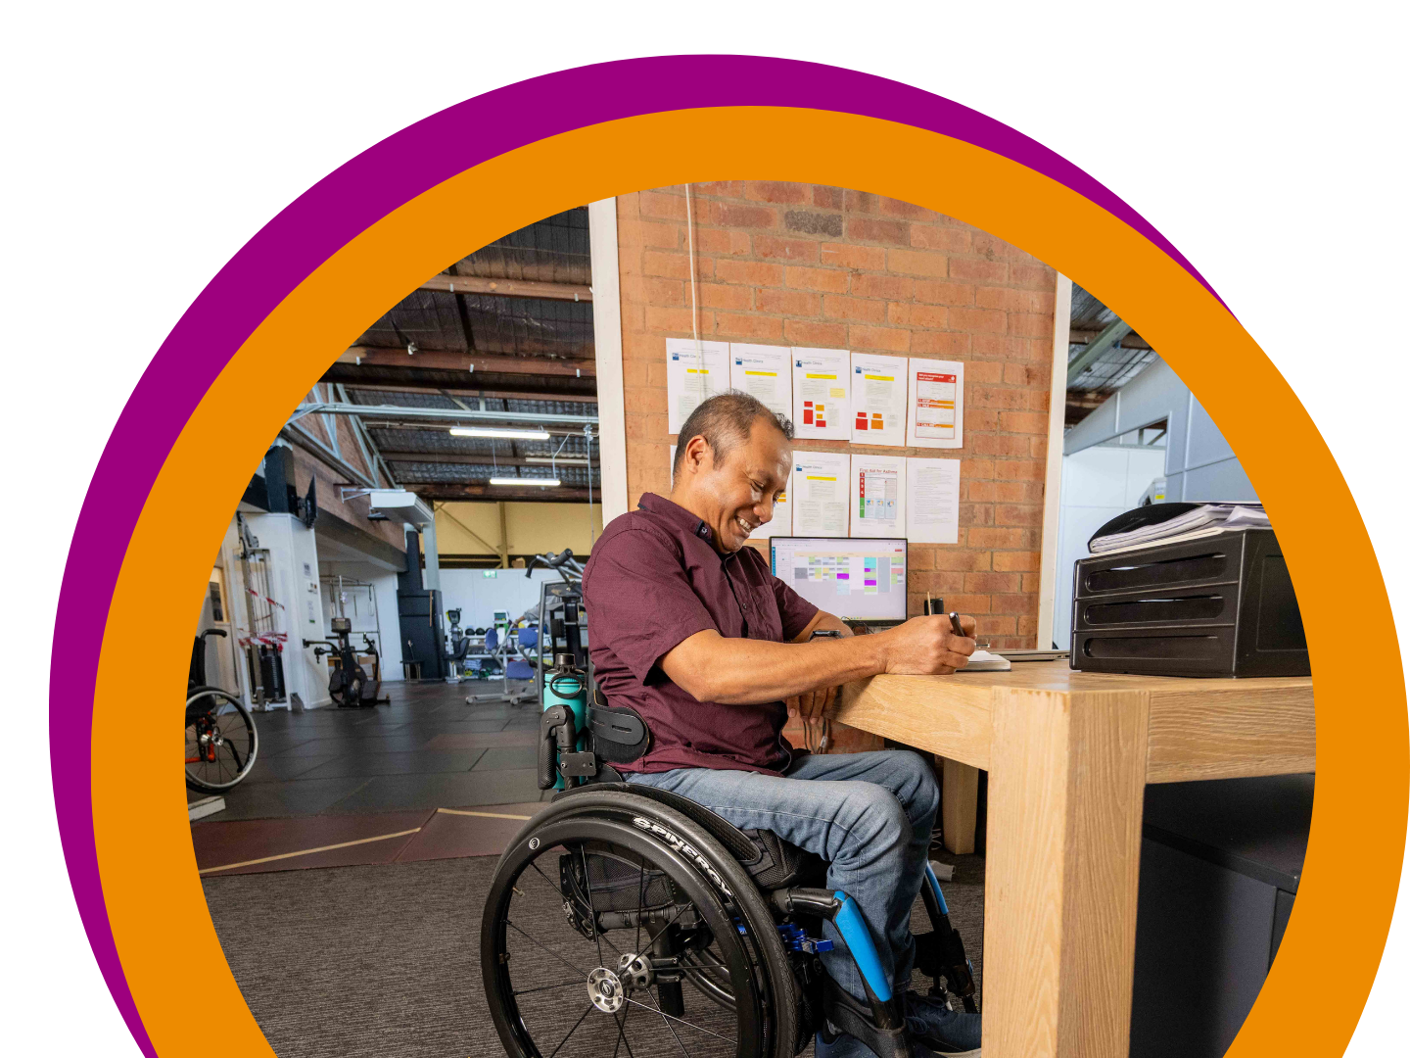
Networking, team building and meetings

Networking

Networking opportunities help your employees develop and improve their skill set, stay on top of the latest trends in their industry, meet prospective mentors, partners, and clients, and gain access to the necessary resources that will foster their career development.xviii
As good practice, organisations must create avenues that allow employees with disability to have the time, space and support to openly discuss their challenges, needs and experiences. Employee Resource Groups (ERGs) or Disability Employee Networks (DENs) can facilitate critical conversations between senior leaders, diversity and inclusion practitioners and employees with disability. They can serve as a valuable platform for employees with disability to communicate their views and opinions to relevant internal stakeholders. They can also act as a reference group to provide input into policies and procedures, allowing diverse voices to be heard and represented within the organisation. ERGs and DENs can also support employees whose friend, parent, spouse, child, or colleague who lives with disability.

“Creating formal groups such as disability employee networks (DENs) with a direct line to an executive sponsor can greatly benefit employees with disability. These provide a valuable platform for sharing information, experiences, initiatives, stories and help build supportive relationships amongst employees. They can also improve vital organisational systems and processes to boost access and inclusion.

At the same time, it’s equally essential to remove barriers for employees with disability in informal networking and development opportunities including team celebrations or team building activities. Building inclusion into the planning of your everyday activities, ensuring no one is left behind.”

Karla Fernee
Manager, National Disability Recruitment Coordinator

Team building

Team building is a continuous process that enables a working group to evolve into a cohesive unit. Whether formal or informal, team building provides opportunities to employees to share expectations, solve problems and develop solid working relationships with co-workers.
Ensure inclusivity is prioritised in all meetings, forums, events, and activities, considering access needs for small team celebrations, through to team building exercises.

Meetings
It is good practice to ensure company meetings are accessible for all participants, including employees with disability.

What you can do:
- Ask the participants if they have any access requirements
- Establish guidelines to encourage each employee to participate freely Schedule frequent breaks as it can help people who might find it challenging to
- concentrate for extended periods, especially if they have hearing difficulties or can’t sit for extended periods
- Ensure any conversations that are fast-paced or rapid / excited are inclusive of all participants, and that all can contribute
- Use inclusive language to create an open and respectful space for discussion

Leadership opportunities

People with disability can have lower visibility at senior levels of business, or as members of boards, or advisory groups. This can be due to unconscious bias of managers who may overlook people with disability for leadership programs.
To combat this, managers can create learning and career development options specifically targeted toward individuals with disability who have an interest in leadership roles — and include them in opportunities that already exist that are open to different talent cohorts.
Employees with disability report strengths such as persistence, discipline, and willingness to commit, but feel employers often don’t see this potential.
According to the latest 2022 Disability Equality Index (DEI) from Disability:IN, 30 per cent of employees mentioned that they have a senior executive who is a person with disability.
While only six per cent of companies have someone with disability in their Board of Directors, 10 per cent of organisations have documents on nominations for board directors that specifically mention the consideration of people with disability.xix
A good leadership program begins by assessing an employee’s decision-making effectiveness. It helps them recognise their strengths and utilise them to become more effective leaders.
These programs also identify weaknesses and provide guidance on how to fill gaps.
Feedback is often requested from colleagues and managers to improve emotional intelligence
— a critical trait for effective leadership.
Aspiring leaders can improve their skills through leadership programs, which teach them how to direct, design teams, give feedback, collaborate, and motivate others.xx
It is highly recommended that companies offer mentoring and coaching initiatives,
as well as skilling/reskilling programs, to ensure that people with disability continue to grow and succeed at all levels, including top leadership positions.
“You can’t be what you can’t see, especially in leadership positions. It helps leadership teams to have diversity, work with that diversity, and reduce perceived challenges, nervousness and anxieties about what inclusion looks like.
A common leadership concern is ‘I hope I’m not doing the wrong thing’ and wanting to be correct in approaching things.

You will get the right outcomes if you come to those conversations with the right intent and an open and solution focused approach. Leaders need to be proactive in bringing talent in, who may be people with disability or mental health conditions. If you focus on outcomes and reducing barriers, there’s much to gain for your teams and customers.”

Sarah Hilt

Group Executive Personal Injury, MedHealth

Make it happen in your workplace
There are a number of strategies that can help people with disability to achieve and obtain meaningful employment and a successful career in the workplace. Here are some key takeaways and actionable suggestions that employers can do to make it happen in your workplace:


Commitment from leadership
A commitment can break down workplace barriers and support professional aspirations of employees with disability. Senior leaders can prioritise inclusion by holding the organisation accountable towards achieving diversity, inclusion metrics and performance.

Cultivate a supportive environment
To achieve disability inclusion, create a supportive workplace that values the skills, experiences, and perspectives of employees with disability. Promote transparency to ensure employees feel comfortable sharing information without fear of negative consequences — whether during an interview or in the boardroom.


Share stories of employees in leadership roles
Employees who are willing to share their stories openly can act as good role models. When open employees or employers participate and engage in networking activities such as ERGs or DENs, they can help create a secure space for others to share their experiences.
Create a business case
Identify why disability inclusion is essential for your organisation and create a business case demonstrating the value of encouraging a diverse and inclusive workforce. Illustrate how it can boost organisational performance and outline the steps you will take to support people with disability across all employment levels.

Get in contact with JobAccess
When in doubt, you and your employees are always welcome to contact JobAccess. We have a range of field experts, including allied health professionals, who offer tailored advice on reasonable adjustments to employers and people with disability, from the first point of contact.
Our team can support you with job redesign or the funding of workplace modifications that enable employees to secure and flourish in their role.
You don’t have to go it alone; we are here to help. Contact JobAccess on 1800 464 800 to speak with our friendly and resourceful Advisers or visit jobaccess.gov.au.

References

- Australia’s Disability Strategy. Key actions under the Strategy. Retrieved from

disabilitygateway.gov.au/ads/key-actions-strategy
- Graffam J, Shinkfield A, Smith K and Polzin, U (2002). Employer benefits and costs of employing a person with a disability. Journal of Vocational Rehabilitation, vol. 17, no. 4, p. 251-263.
- Australian Safety and Compensation Council. (2007). Are People with Disability at Risk at Work? A Review of the Evidence, ASCC, Canberra, Du Paul University.
- Kalargyrou, V. (2012). People with disabilities: A new model of productive labor. Proceeding of the 2012 advances in Hospitality and Tourism Marketing and Management Conference. Corfu, Greece.
- American Association of People with Disabilities (AAPD) and Disability:IN. Disability Equality Index. (2023). Retrieved from disabilityin-bulk.s3.amazonaws.com/ DEI+2023+Report_Final+508.pdf
- Design for dignity. Inclusive design for Australian organisations. Retrieved from

designfordignity.com.au
- JobAccess. Employer Toolkit. Getting your workplace ready. Employment Assistance Fund. Retrieved from jobaccess.gov.au/i-am-an-employer/employer-toolkit/getting-your- workplace-ready
- Office of the Australian Information Commissioner. Retrieved from oaic.gov.au
- National Public Radio. Understanding unconscious bias. (2020). Retrieved from

npr.org/2020/07/14/891140598/understanding-unconscious-bias
- Australian National University. Unconscious bias. (2015). Retrieved from anu.edu.au/

sites/prod.gaia-web.anu.edu.au/files/resource/Unconscious%20Bias.pdf
- Perry, Elissa & Hendricks, Wallace & Broadbent, Emir. (2000). An Exploration of Access and Treatment Discrimination and Job Satisfaction among College Graduates with without Physical Disabilities. Human Relations - HUM RELAT. 53. 923-955. journals.sagepub.com/doi/10.1177/0018726700537002
- Sherbin L, Kennedy J T. Center for Talent Innovation. Disabilities and inclusion. Global and U.S. findings. (2013). Retrieved from coqual.org/wp-content/uploads/2020/09/ CoqualDisabilitiesInclusion_KeyFindings090720.pdf
- Disabled Person. Career Development for People with Disability. Retrieved from

disabledperson.com/careeer-development-pwd
- US Equal Employment Opportunity Commission. Applying performance and conduct standards to Employees with Disability. Retrieved from eeoc.gov/laws/guidance/ applying-performance-and-conduct-standards-employees-disabilities

- DeFreitas T. Job Accommodation Network. Performance Management and People with Disability, Retrieved from askjan.org/articles/Performance-Management-and-Employees- with-Disability.cfm
- Shmerling L. Australian Careers Service. Mentoring in the workplace: benefits for career development. Retrieved from australiancareersservice.com.au/industry-news/mentoring- workplace-benefits-career-development
- ALSCO. Impressive Benefits for Employee Training and Education. (2018) Retrieved from

alsco.com.au/2018/02/10-impressive-benefits-employee-training-education
- McEachran R. The Guardian. Networking with a disability: how to overcome the challenges. (2013). Retrieved from theguardian.com/careers/careers-blog/networking-with-a- disability-overcome-challenge
- American Association of People with Disabilities (AAPD) and Disability:IN. Disability Equality Index. (2022). Retrieved from disabilityin-bulk.s3.amazonaws.com/2022/ DEI+2022+Report+Final+508.pdf
- Ryan C, Our Community. The critical need for disability leadership. Retrieved from

ourcommunity.com.au/general/general_article.jsp?articleId=7475%22

jobaccess.gov.au 1800 464 800
Follow JobAccess on LinkedIn
Subscribe to the JobAccess channel on YouTube

