Employment Assistance Fund (EAF)

Online Application – Instructions

This guide provides step-by-step instructions on how to apply for the Employment Assistance Fund (EAF) online via the JobAccess Secure page.

If you need workplace modifications/equipment or other services and meet the eligibility criteria, you can apply online for the Employment Assistance Fund (EAF). The [EAF Guidelines](https://www.jobaccess.gov.au/downloads/employment-assistance-fund-guidelines) detail information about who is eligible, how the application process works and the evidence you need to support your application and reimbursement.

Please do not order or purchase any items prior to receiving written approval, as JobAccess is unable to make any retrospective payments.

# Frequently Asked Questions?

<https://www.jobaccess.gov.au/employment-assistance-fund-eaf>

The JobAccess team is able to assist with queries or questions by contacting 1800 464 800 or emailing [jobaccessadvice@workfocus.com](mailto:jobaccessadvice@workfocus.com)

# New users: to use the site for the first time

If you are a new user, you will need to register to use the site for the first time (Steps 3 & 4).

Note: Once you have registered you will be given a User ID – please record your User ID and password somewhere safe, as you will need this for future applications. Please note that the system does not generate an email with your log in details, so please record it somewhere safe.

# Existing users: use previously supplied details

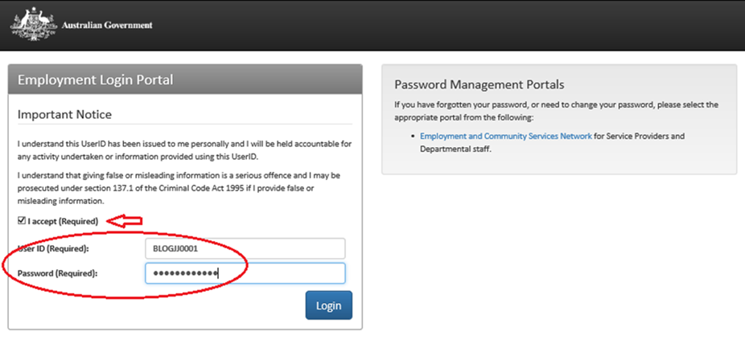Click the relevant log in (either Employer, Self Registered or Service Provider) and log in with the previously supplied User ID and chosen password (Step 5).

1. Go to the [JobAccess home page](https://www.jobaccess.gov.au/home).
2. 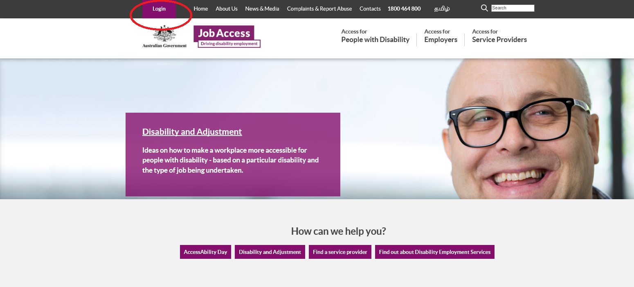Click on ‘Login’, on the top left hand side of the JobAccess home page.

This will display the [JobAccess Secure page](https://ecsn.gov.au/JOBACCESsSECURE/JAS).

1. If you are a new user, click on the ‘Register’ link.
2. You will be asked to come up with a password (the password rules are listed on the page). Please record your log in details down and keep safe to use next time.
3. 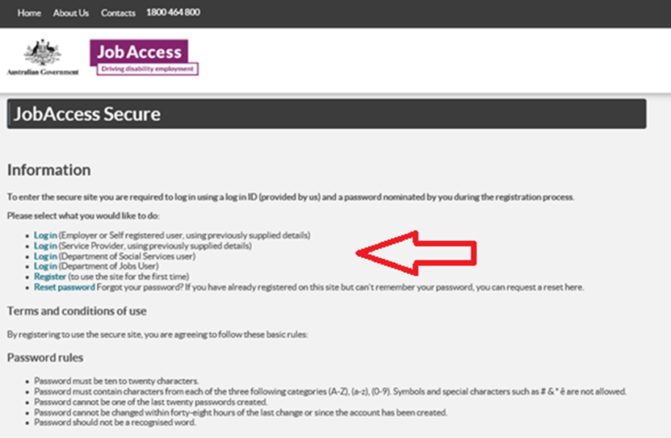If you are a returning user, select the relevant ‘Log in’ with the previously supplied username and your password that you recorded.
4. Tick ‘I accept’ to agree to the privacy notice “I understand that this UserID has been issued to me personally and I will be held accountable for any activity undertaken or information provided using this UserID. I understand that giving false or misleading information is a serious offence and I may be prosecuted under Section 137.1 of the Criminal Code Act 1995 if I provide false or misleading information.”

After you have logged in and agreed to the Privacy Notice, the Welcome Page will display.

1. 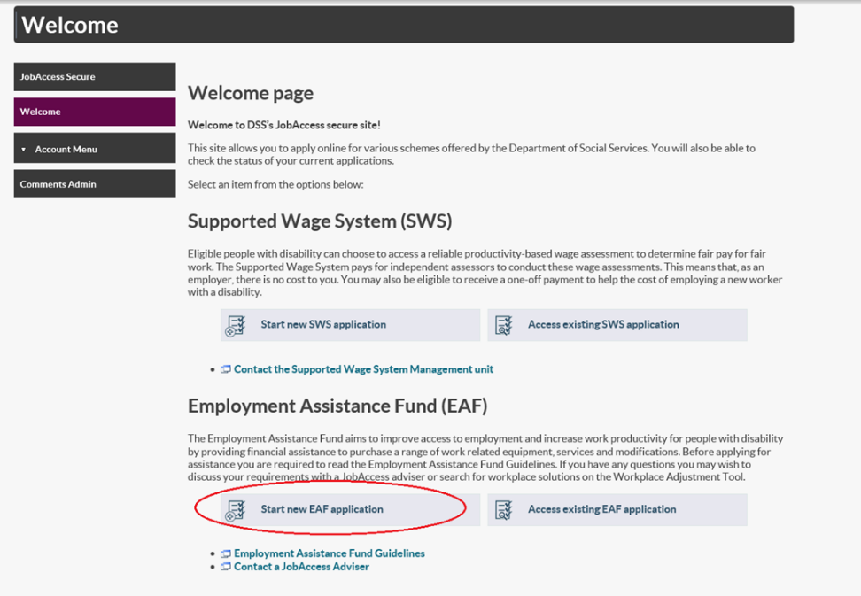Click on ‘Start New EAF application’.

Individuals (self-employed/employees), Employers, ADEs, or Service Providers can lodge an EAF application.

1. 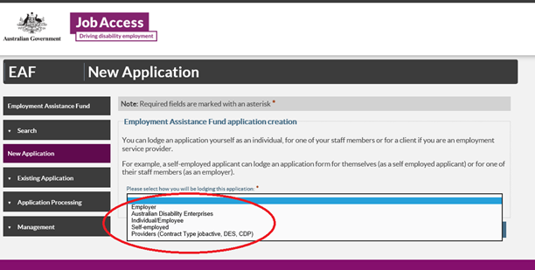Select who will be lodging the application from the drop down list and then click next at the bottom on the page.

The sites terms and conditions then display.

1. 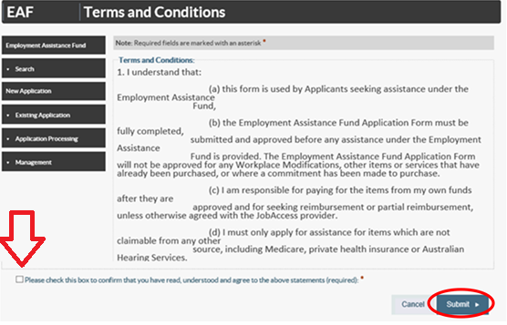You must tick the box at the bottom of the page and then click submit to proceed.

# Application form

Note: All fields marked with an asterisk**\*** are mandatory.

1. There are five steps/tabs to the online application and you need to complete all five steps – use the ‘Previous’ and ‘Next’ buttons to navigate through the application tabs.

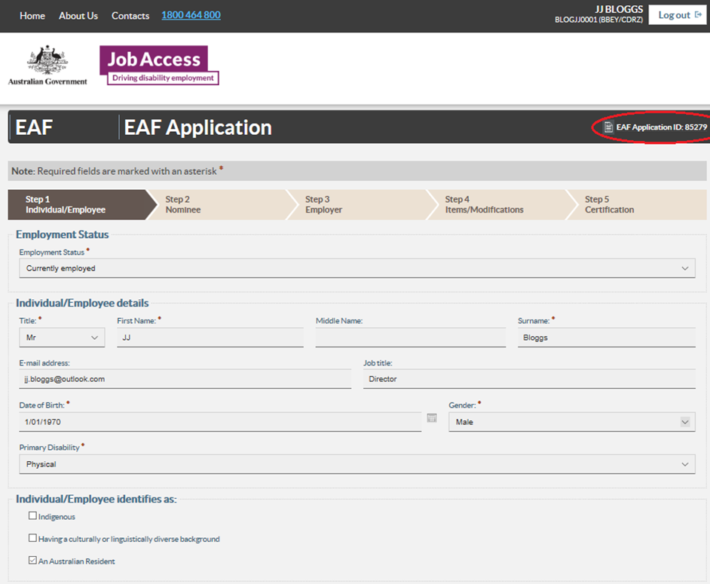Your EAF Application ID number will display at the top right corner.

1. Fill in your personal details at Step 1 – Individual / Employee.
2. If someone is acting on your behalf, select ‘yes’ and complete all fields at Step 2 – Nominee and then select the Next button.
3. Provide details of your Employer at Step 3 – Employer. To look up your employer’s ABN go to <http://www.abr.business.gov.au/>
4. Click ‘Add’ at Step 4 – Items / Modification and then enter details.

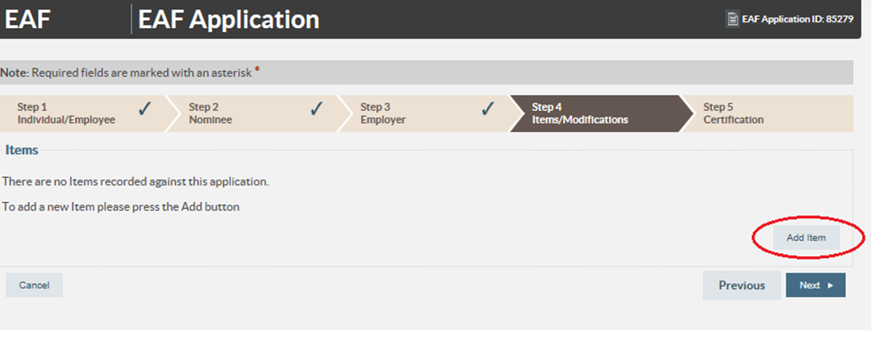

1. Under ‘Item Type’ (if you are not applying for Auslan Interpreting Services or training) then select ‘Other’ and under ‘description’ type in the description of the item.

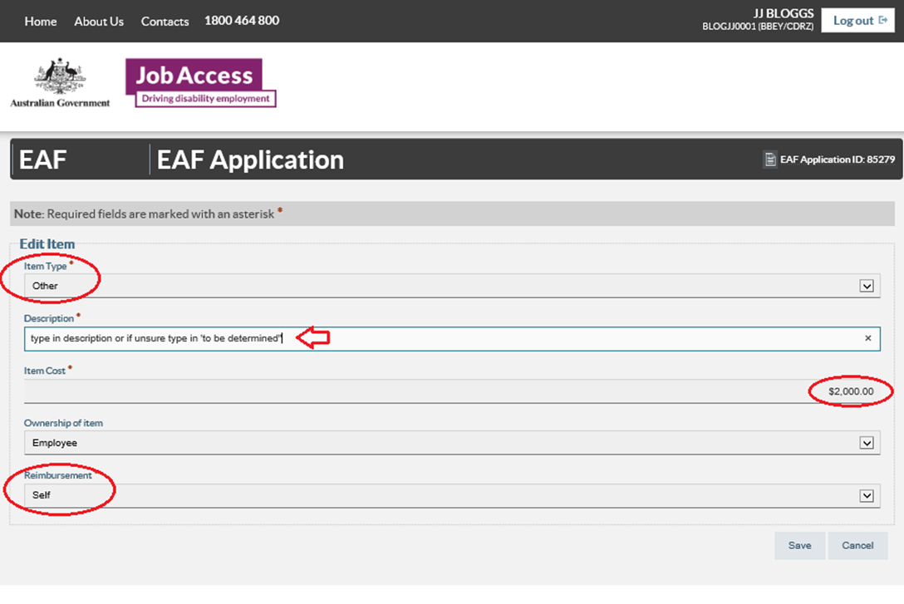Note: If you are unsure what to type enter “to be determined” and go to the next tab.

1. Under ‘Item Cost’ enter the cost of the item, or if you are unsure enter $0.00.
2. Under ‘Ownership’ select the owner of the item (the owner is generally always the employee with disability, unless the funding is for a building modifications or by agreement with JobAccess, the employee and employer).
3. Under ‘Reimbursement’ select who will be paying for the item, if your application is approved. This is who JobAccess will reimburse the funds to following proof of purchase.
4. 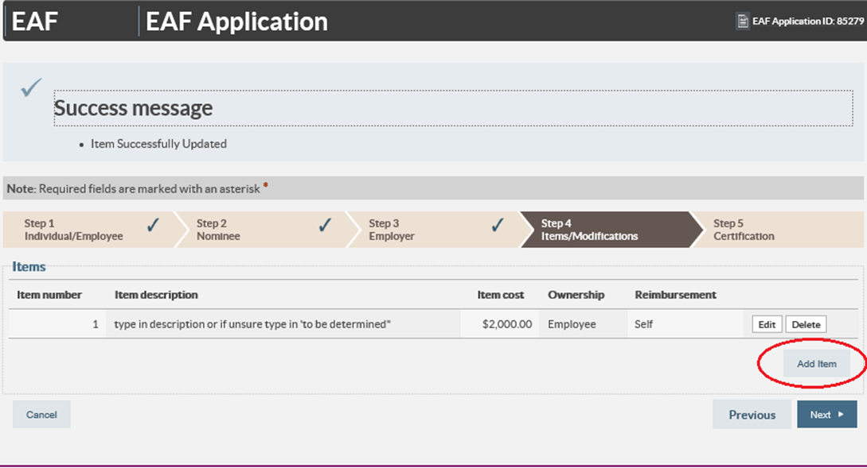Click ‘Save’ and then the either click ‘Add’ to include another item or click ‘Next’ to proceed to Step 5.
5. 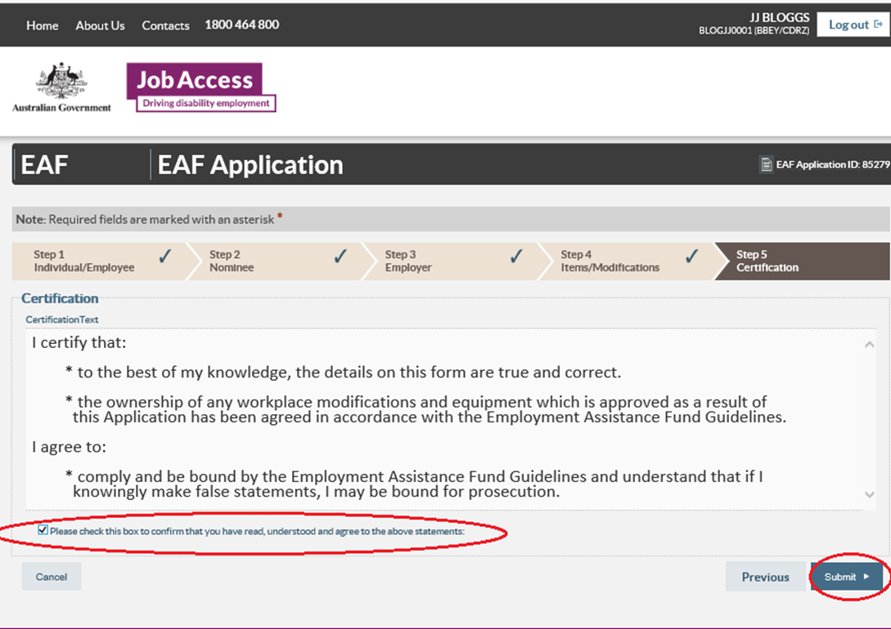Read and tick the box at the bottom of Certification tab, then click ‘Submit’. JobAccess will then process the application and contact you within 2 working days.
6. 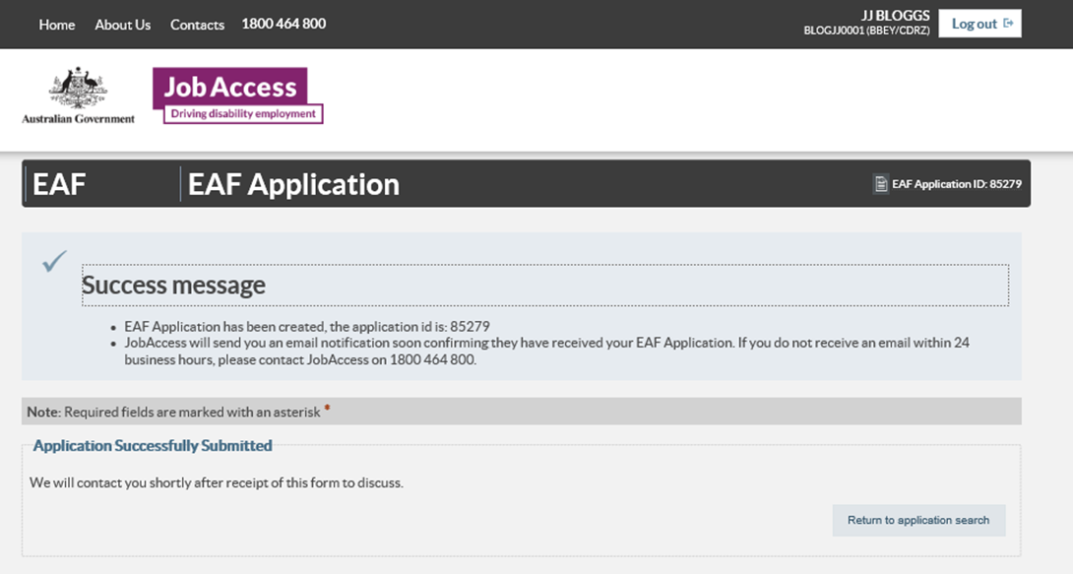If you do not receive a ‘Success message’ with an application ID number, please contact JobAccess on 1800 464 800 as your application did not save correctly.

**Please do not order or purchase any items prior to receiving written approval, as JobAccess is unable to make any retrospective payments.**

The EAF is a reimbursement fund and JobAccess can only reimburse approved applicants after you have supplied proof of purchase. Evidence for claiming reimbursement is listed in the EAF Guidelines.