Supported Wage System (SWS)
  - Online Application – Instruction
This guide provides step-by-step instructions on how to apply for the Supported Wage System (SWS) online via the JobAccess Secure page.
The Supported Wage System (SWS) is set up for employees with disability who are not able to perform jobs at the same capacity as any other employee. It allows you to match an appropriate wage with the productivity of a person with disability
Please refer to the SWS Handbook and Overview of the Supported Wage System for further information.

Frequently Asked Questions?
https://www.jobaccess.gov.au/supported-wage-system-sws
Contact the Department of Social Services Assessment Team on 1800 065 123 or speak to a JobAccess Adviser on 1800 464 800.

Accessing the Secure Application site
Go to the JobAccess home page.

- Click on “EAF/SWS Login” on the top left-hand side of the JobAccess Home page.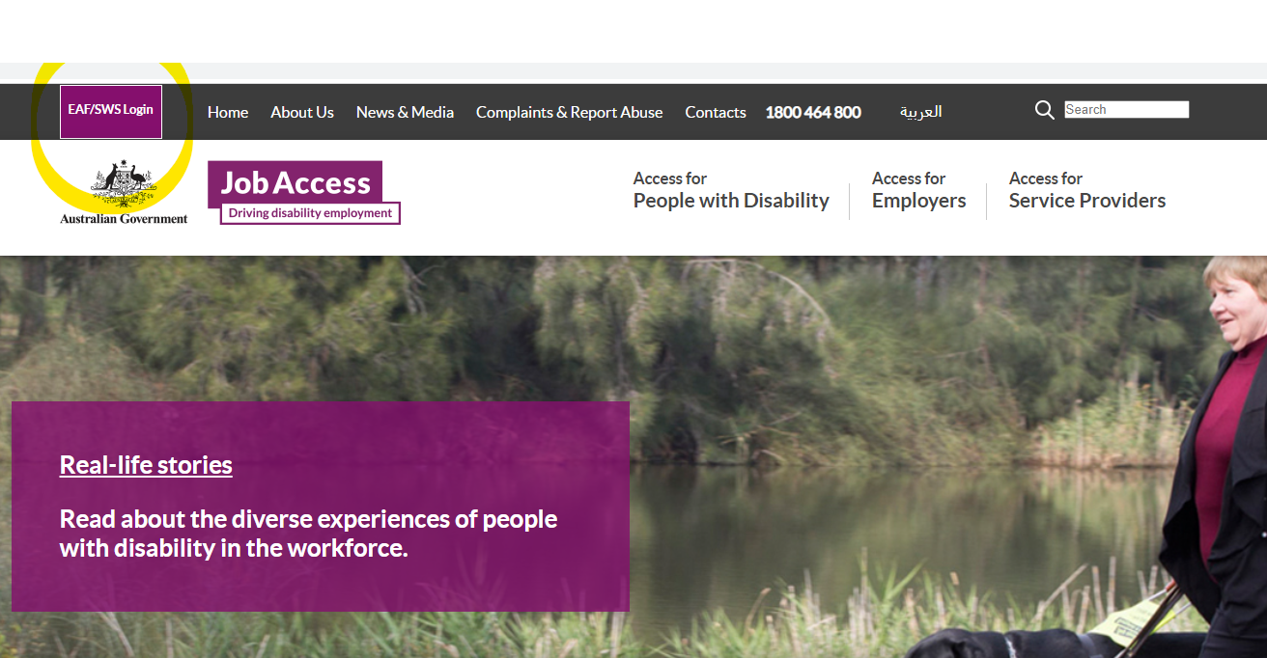

- This will display the JobAccess Secure page.

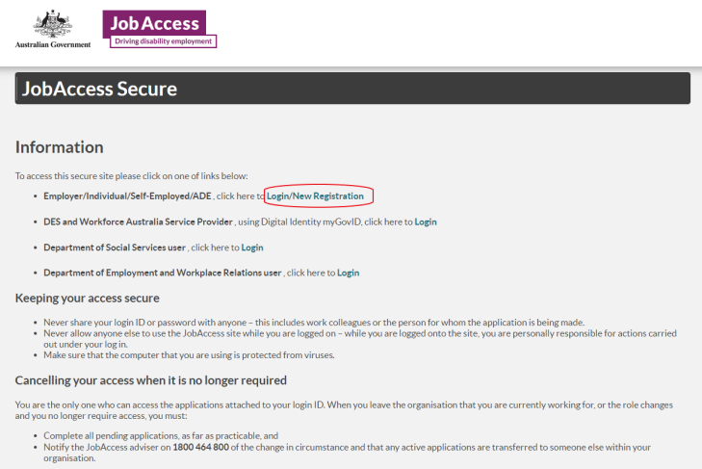

Use the top option to make a ‘Login/New Registration’ if you are new to the SWS process. You will be redirected to ‘Sign-in with myGov’ for verification of your digital identity before you proceed to lodge an application.
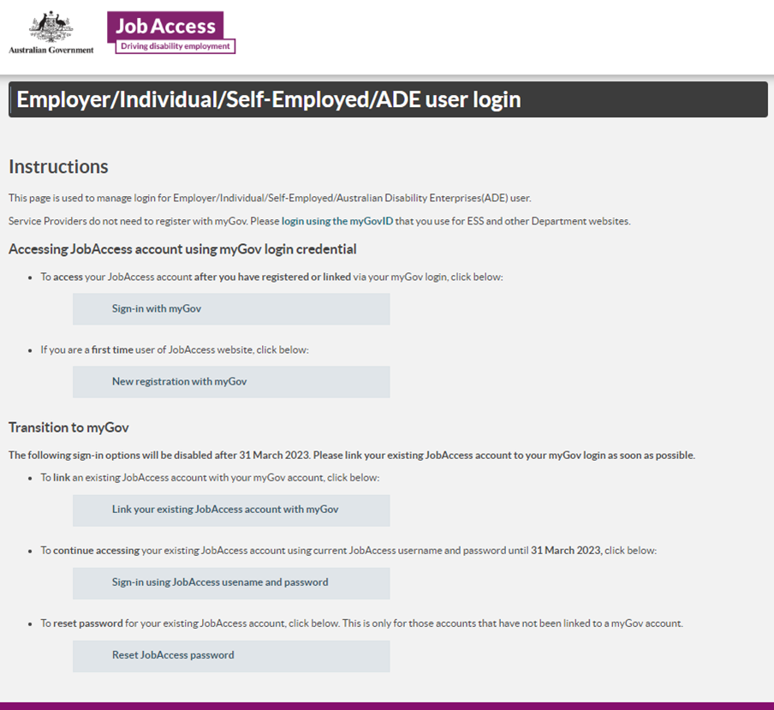
Signing in as an Employer/Individual/Self-Employed/ADE user

New Registration with myGov account
From 3 Dec 2022 new account registration users need to click on the button and use your myGov account details to register.
Once you click on this button, on the next screen you need to:
- Select user type from one of the following groups:
  - Australian Disability Enterprises
  - Individual or Employee
  - Self-Employed
  - Employer
- Then click on the ‘Register with myGov’ button
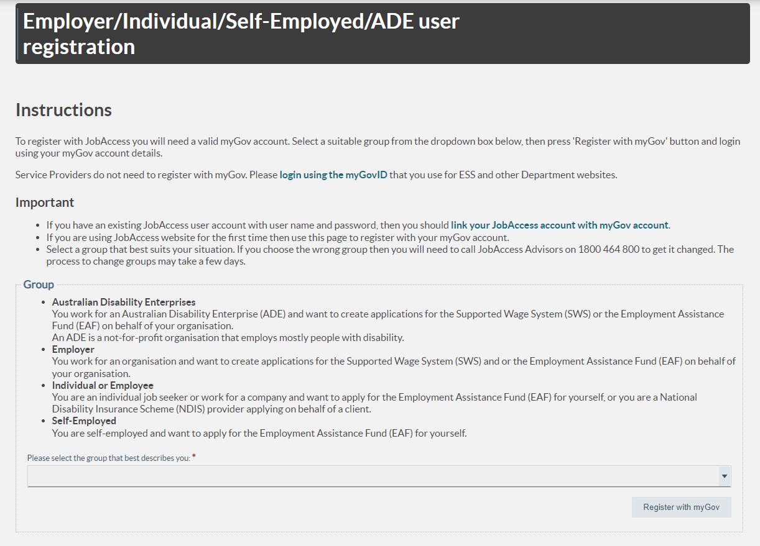

- You will be re-directed to the myGov login screen to enter your myGov username and password and then to accept the myGov terms of use
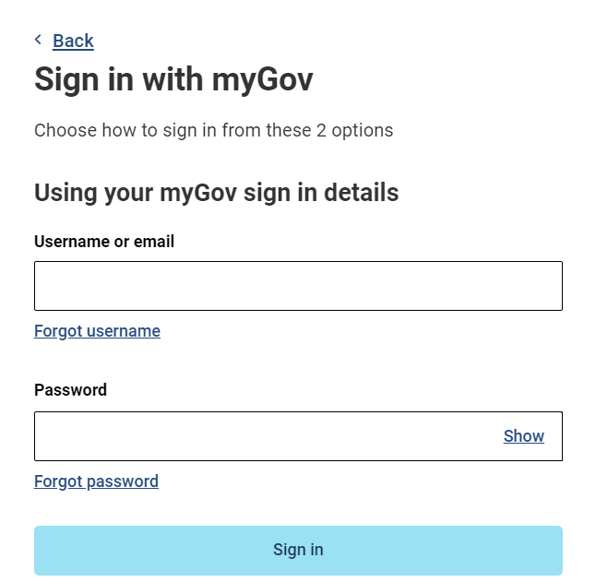
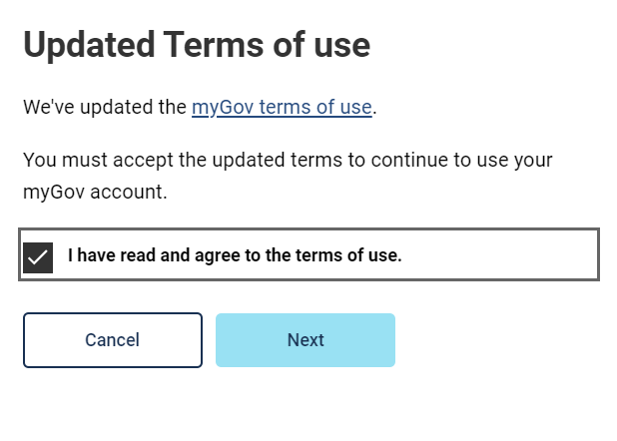
Blue arrow

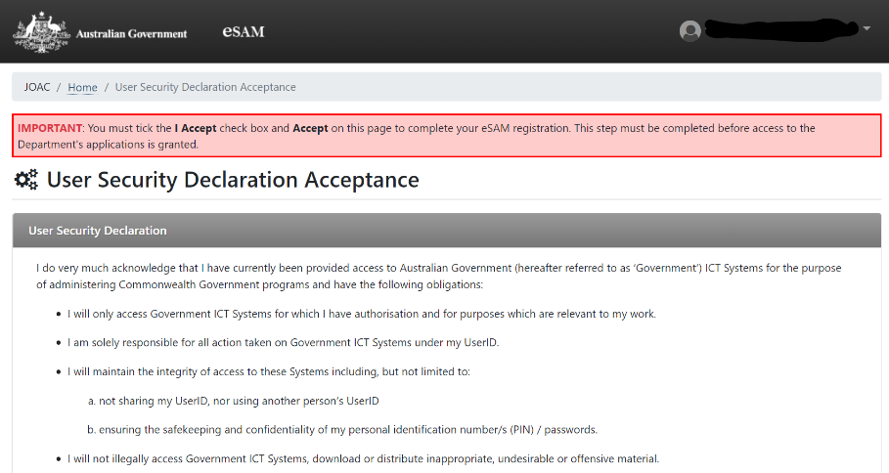
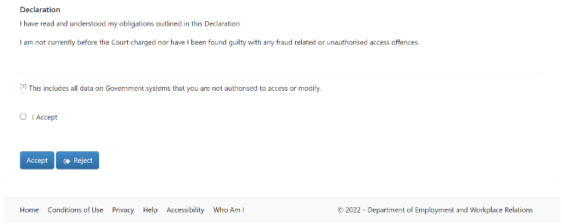
- You will then be re-directed to the Department of Employment and Workplace Relations’ eSAM page to accept the ‘User Security Declaration Acceptance’ form and complete the registration.

- Upon accepting the declaration, the registration is completed, and you are now on DEWR’s eSAM page.
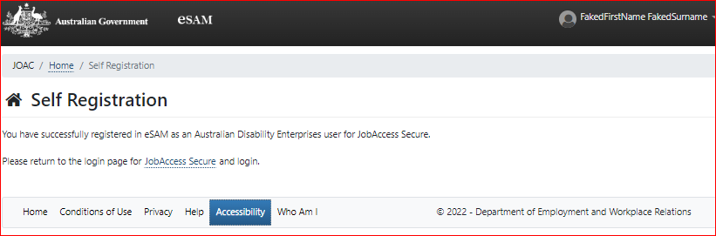

- To complete the registration, you will need to click on the JobAccess Secure link from the page which will re-direct you to the login screen.

- From here on in, you can login to the JobAccess website just by using the ‘Sign-in with myGov’ button.

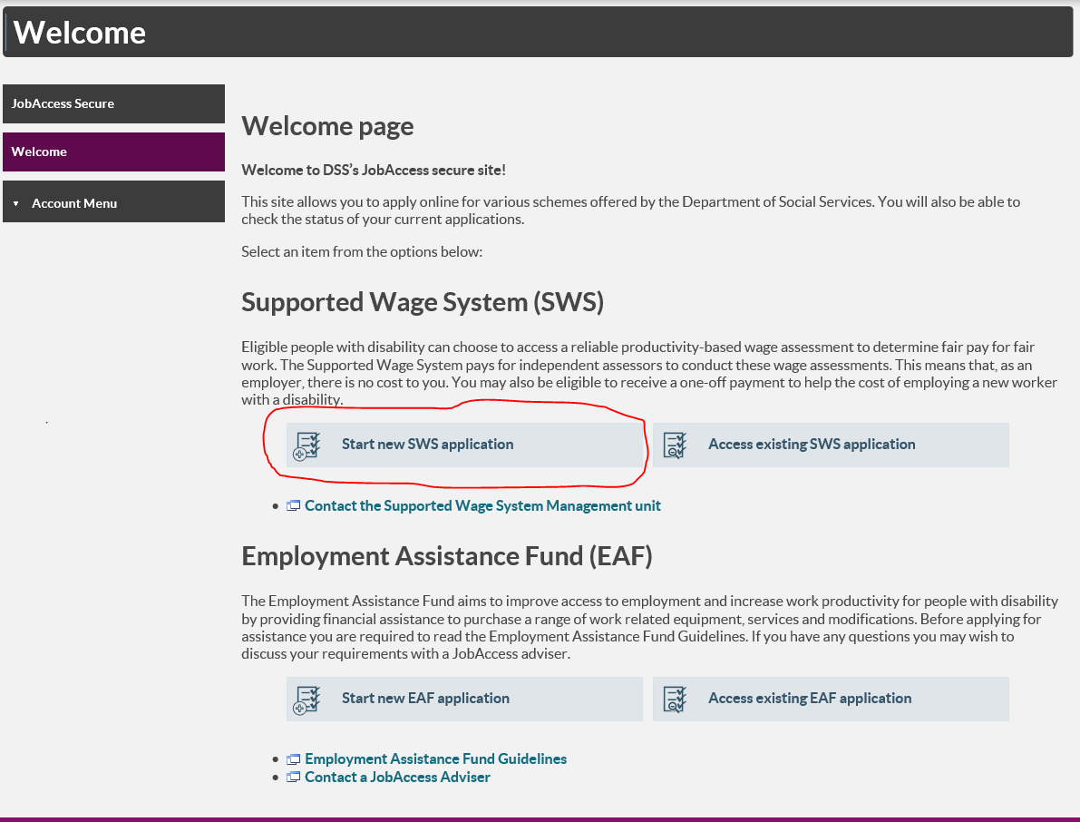
- Click on ‘Start New SWS application’.
Employers, ADEs, or Service Providers can lodge an SWS application.
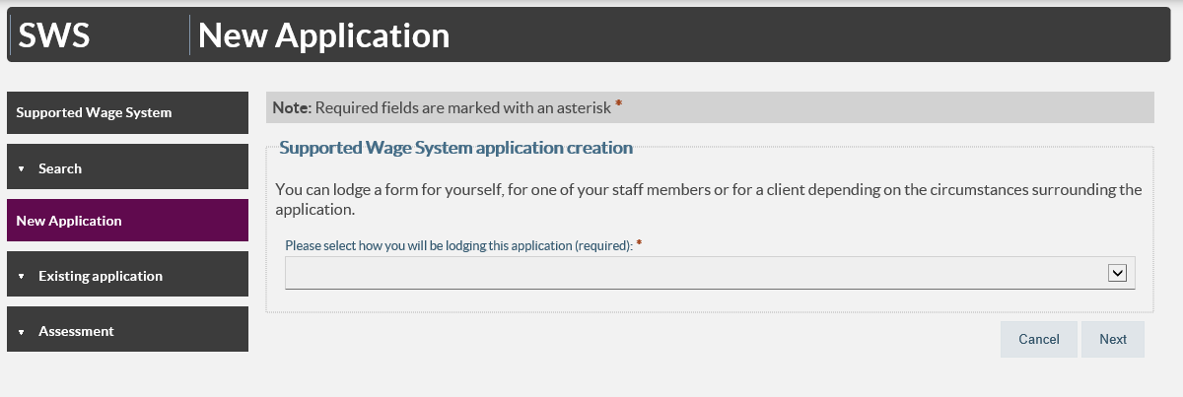
- Select who will be lodging the application from the drop down list (Employer, ADE or Service Provider) and then click next at the bottom on the page.
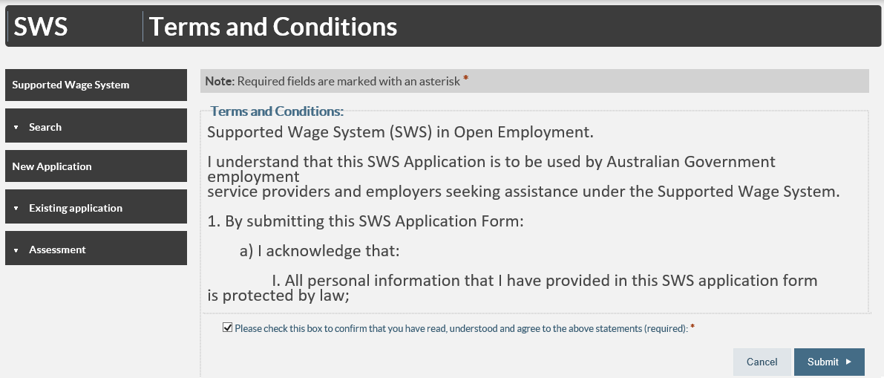
The site’s terms and conditions then display.
- You must tick the box at the bottom of the page and then click submit to proceed.

Application form
Note: All fields marked with an asterisk* are mandatory.
- There are five steps/tabs to the online application and you need to complete all five steps – use the ‘Previous’ and ‘Next’ buttons to navigate through the application tabs.
Your SWS Application ID number will display at the top right corner.
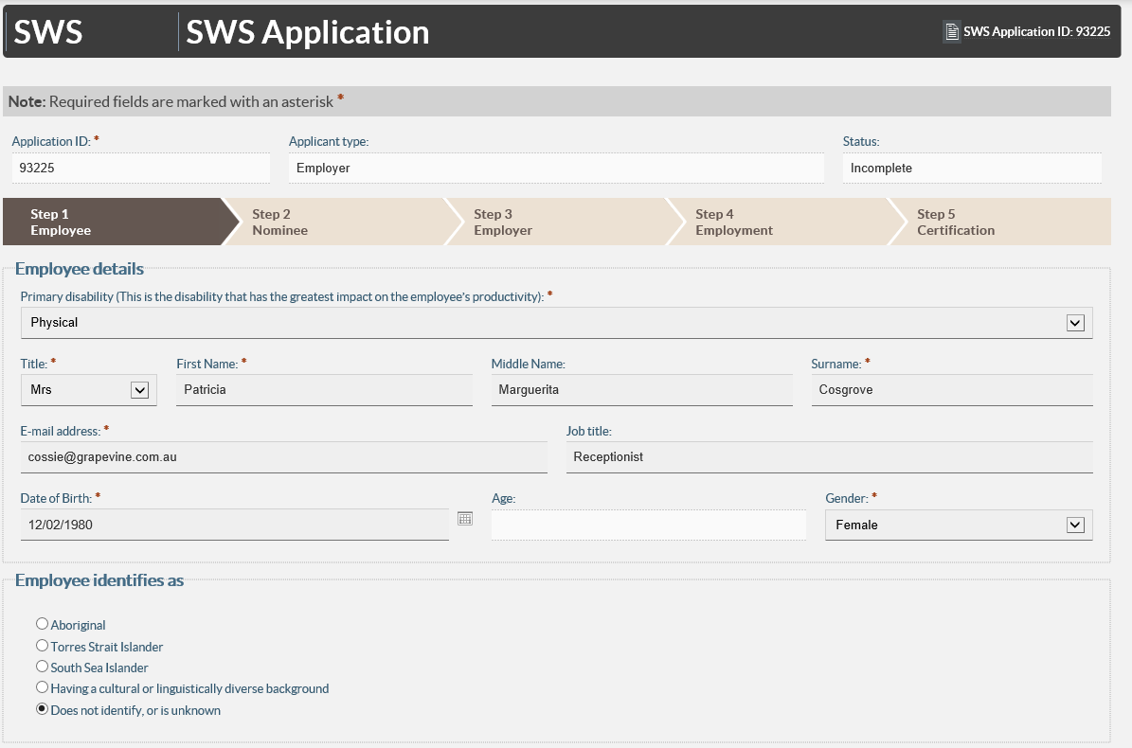
- Fill in your personal details at Step 1 – Individual / Employee.
- Click ‘Save/Next’ to proceed to Step 2.
- Complete Nominee details at Step 2 - Select ‘yes’ and complete all fields if a nominee is acting on the employee’s behalf, and then select the Next button.
- Click ‘Save/Next’ to proceed to Step 3 – Employer.
- Provide details of Employer at Step 3.To look up your employer’s ABN go to http://www.abr.business.gov.au/
- Click ‘Save/Next’ to proceed to Step 4. Employment Details.
- Complete Employment details at Step 4.
- Click ‘Save/Next’ to proceed to Step 5 - Certification.
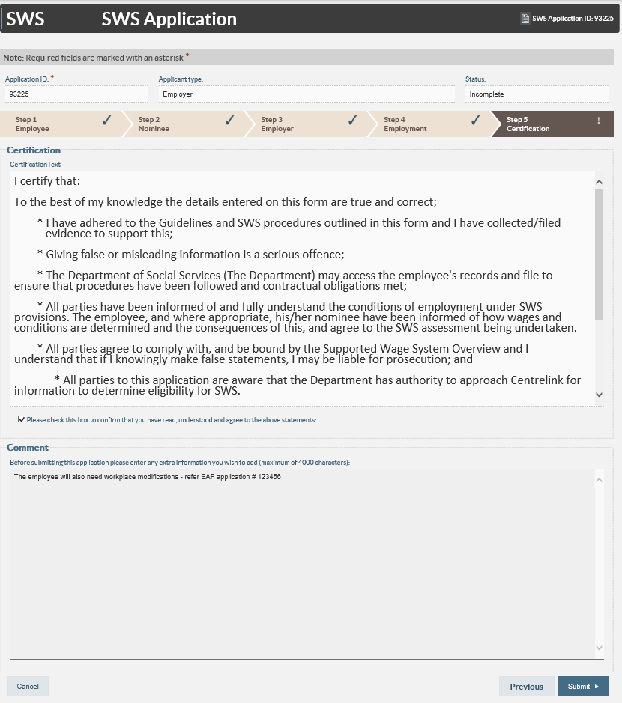
- Read and tick the box at the bottom of Certification tab, add any additional information that may be relevant such as an Employment Assistance Fund (EAF) application for workplace modifications. Click ‘Submit’. The Department of Social Services Assessment Team will process the application and contact you.
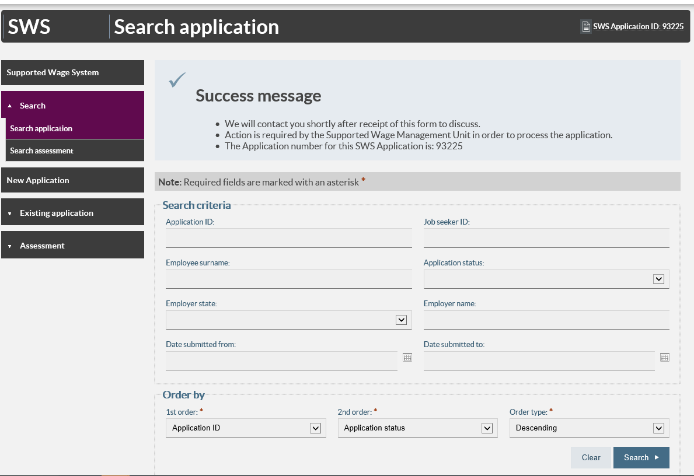
- If you do not receive a ‘Success message’, please contact the Assessment Team on 1800 065 123.

