Employment Assistance Fund (EAF)

Online Application – Instructions

This guide provides step-by-step instructions on how to apply for the Employment Assistance Fund (EAF) online via the JobAccess Secure page.
If you need workplace modifications/equipment or other services and meet the eligibility criteria, you can apply online for the Employment Assistance Fund (EAF). The EAF Guidelines detail information about who is eligible, how the application process works and the evidence you need to support your application and reimbursement.
Please do not order or purchase any items prior to receiving written approval, as JobAccess is unable to make any retrospective payments.

Frequently Asked Questions?
https://www.jobaccess.gov.au/employment-assistance-fund-eaf
The JobAccess team is able to assist with queries or questions by contacting 1800 464 800 or emailing jobaccessadvice@workfocus.com

Accessing the Secure Application site
Go to the JobAccess home page.
- Click on “EAF/SWS Login” on the top left-hand side of the JobAccess Home page.
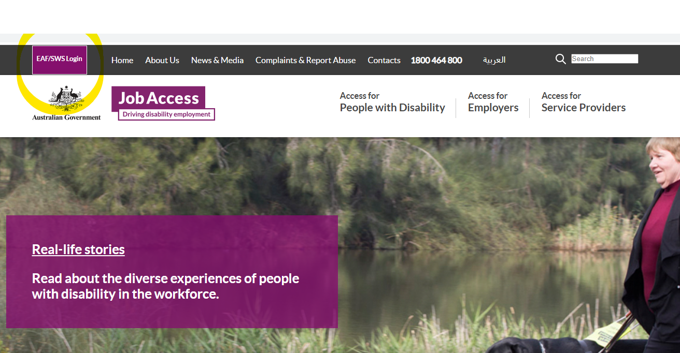

- This will display the JobAccess Secure page.

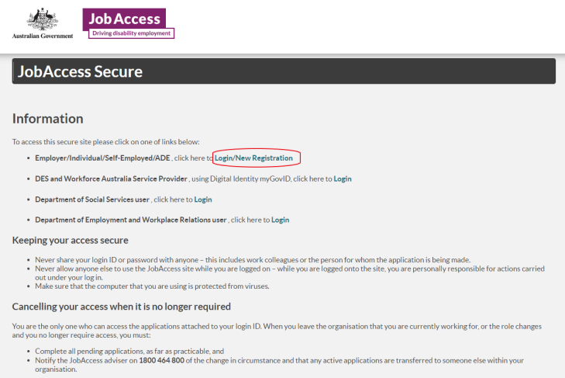

Use the top option to make a ‘Login/New Registration’ if you are new to the EAF process. You will be redirected to ‘Sign-in with myGov’ for verification of your digital identity before you proceed to lodge an application.
Signing in as an Employer/Individual/Self-Employed/ADE user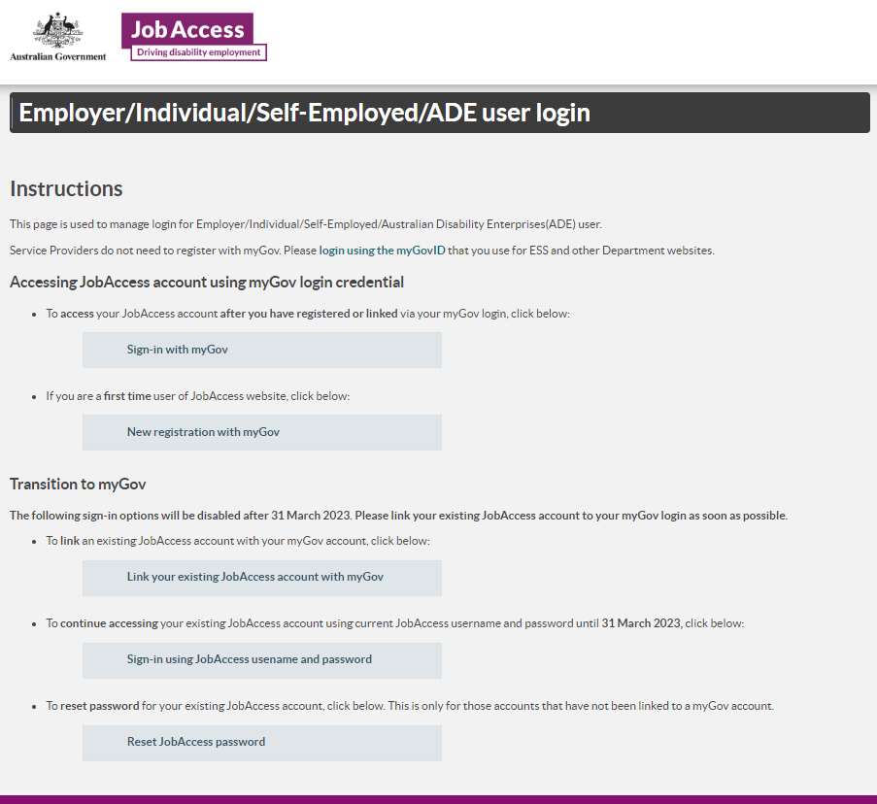

New Registration with myGov account
From 3 Dec 2022 new account registration users need to click on the button and use your myGov account details to register.
Once you click on this button, on the next screen you need to:
- Select user type from one of the following groups:
  - Australian Disability Enterprises
  - Individual or Employee
  - Self-Employed
  - Employer
- Then click on the ‘Register with myGov’ button
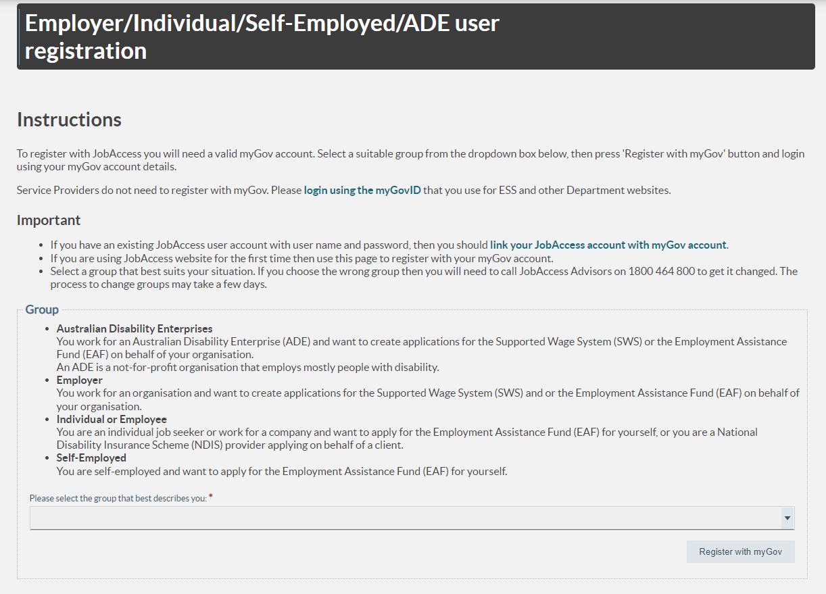
- You will be re-directed to the myGov login screen to enter your myGov username and password and then to accept the myGov terms of use
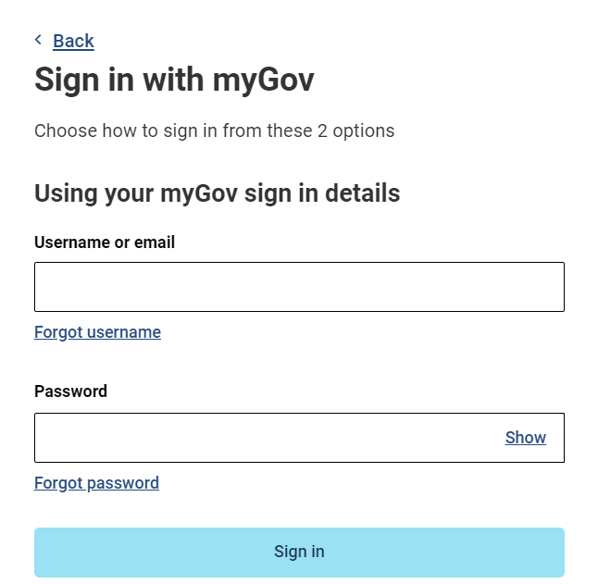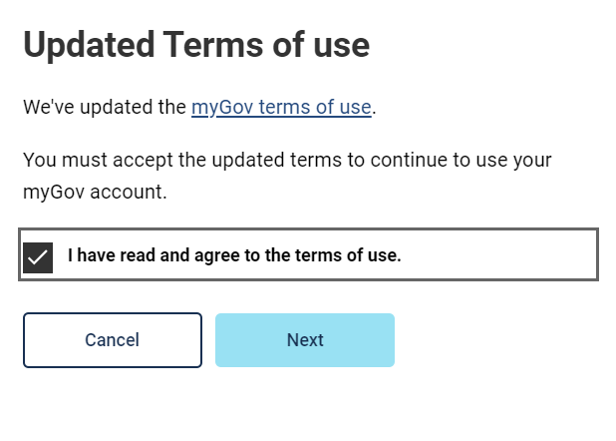
Blue arrow

- You will then be re-directed to the Department of Employment and Workplace Relations’ eSAM page to accept the ‘User Security Declaration Acceptance’ form and complete the registration.
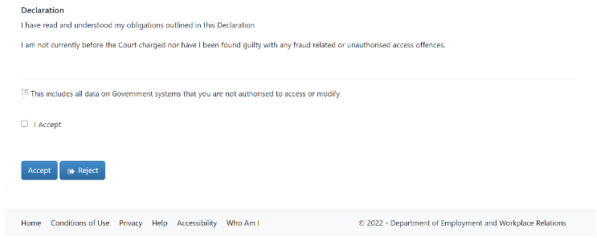
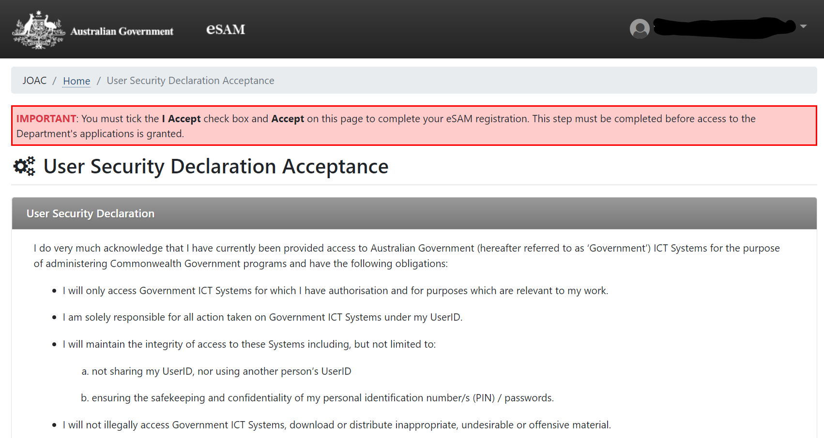
- Upon accepting the declaration, the registration is completed, and you are now on DEWR’s eSAM page.

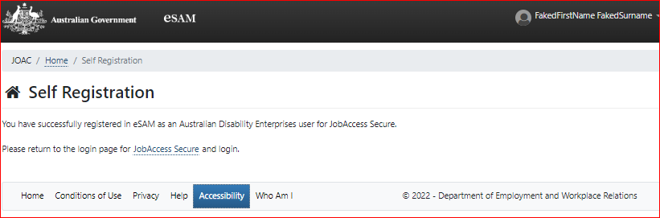
- To complete the registration, you will need to click on the JobAccess Secure link from the page which will re-direct you to the login screen.

- From here on in, you can login to the JobAccess website just by using the ‘Sign-in with myGov’ button.

Lodging an Application
- After reading the Privacy Notice, click on the “Proceed” button commence the application.
- After you have logged in and agreed to the Privacy Notice, the Welcome Page will display.
- Individuals (self-employed/employees), Employers, ADEs, or Service Providers can lodge an EAF application.
- Click on ‘Start New EAF application’.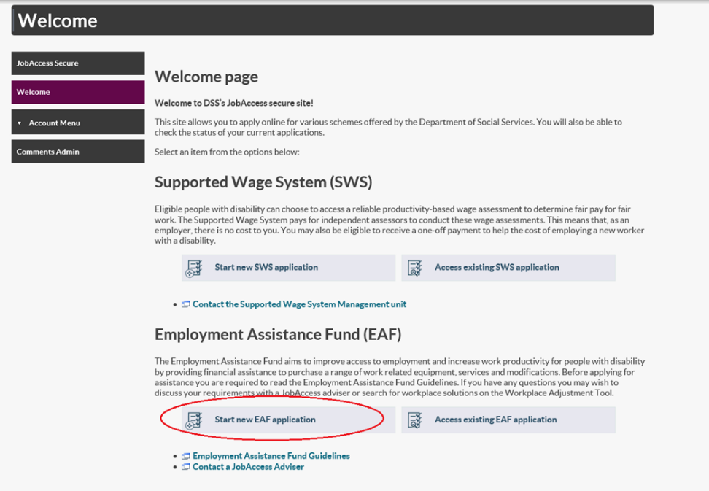

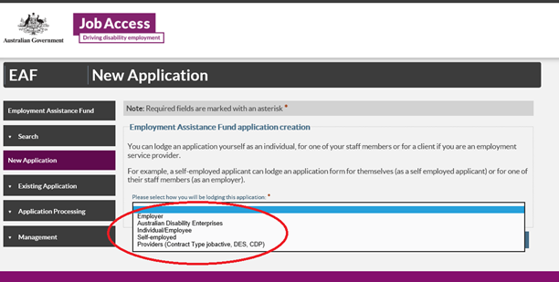
- Select who will be lodging the application from the drop-down list and then click next at the bottom on the page.

- The sites terms and conditions then display.
- You must tick the box at the bottom of the page and then click submit to proceed.
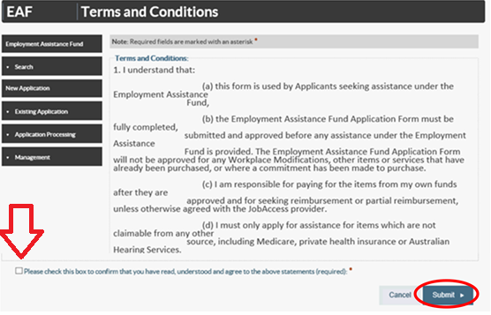
Application form
- Note: All fields marked with an asterisk* are mandatory.
- There are five steps/tabs to the online application, and you need to complete all five steps – use the ‘Previous’ and ‘Next’ buttons to navigate through the application tabs
- Your EAF Application ID number will display at the top right corner

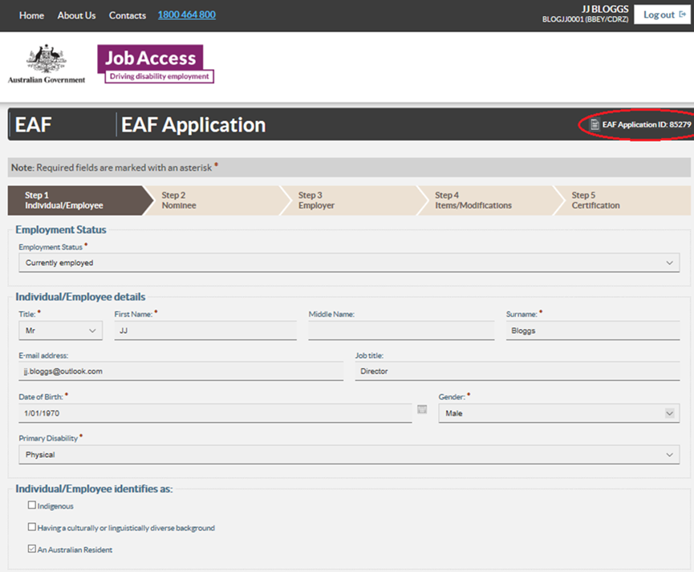

- Fill in the individual’s personal details at Step 1 – ‘Individual / Employee’.
- If someone is acting on their behalf, select ‘yes’ and complete all fields at Step 2 – ‘Nominee’ and then select the Next button.
- Provide details of the Employer at Step 3 – ‘Employer’. To look up your employer’s ABN go to http://www.abr.business.gov.au/
- Click ‘Add’ at Step 4 – Items / Modification and then enter details.
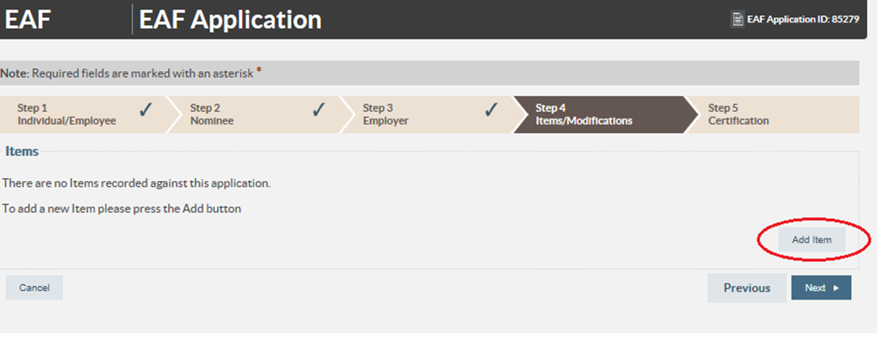
- Under ‘Item Type’ (if you are not applying for Auslan Interpreting Services or training) then select ‘Other’ and under ‘description’ type in the description of the item.
- Note: If you are unsure what to type enter “to be determined” and go to the next tab.
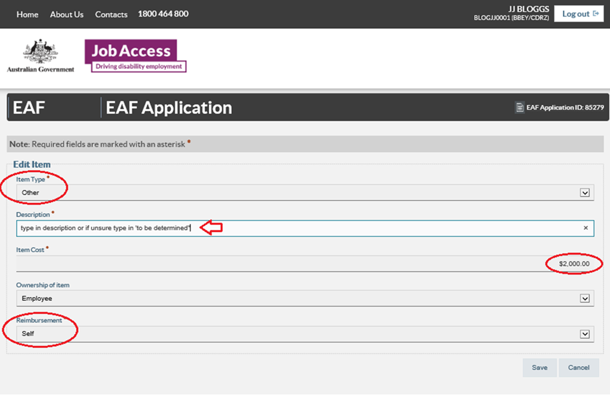
- Under ‘Item Cost’ enter the cost of the item, or if you are unsure enter $0.00.

- Under ‘Ownership’ select the owner of the item (the owner is generally always the individual/employee with disability, unless the funding is for a building modification or by agreement with all parties).
- Under ‘Reimbursement’ select who will be paying for the item, should your application be approved. This is who JobAccess will reimburse the funds to following proof of purchase. The preference is for the employer to assist here.
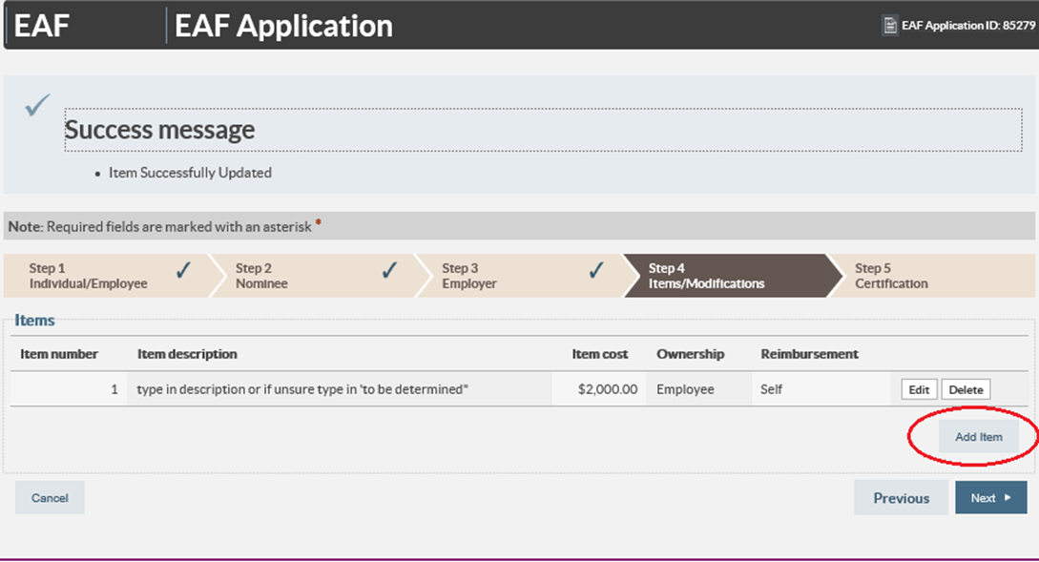
- Click ‘Save’ and then the either click ‘Add Item’ to include another item or click ‘Next’ to proceed to Step 5, ‘Certification’.

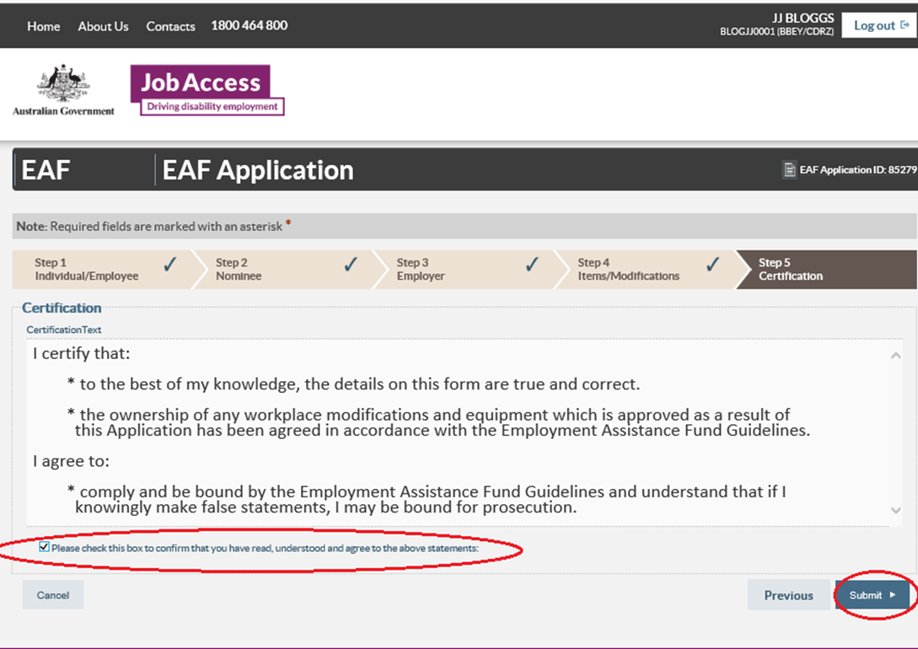
- Read and tick the box at the bottom of the certification tab, then click ‘submit’. JobAccess will then process the application and contact you within two working days to progress the application.
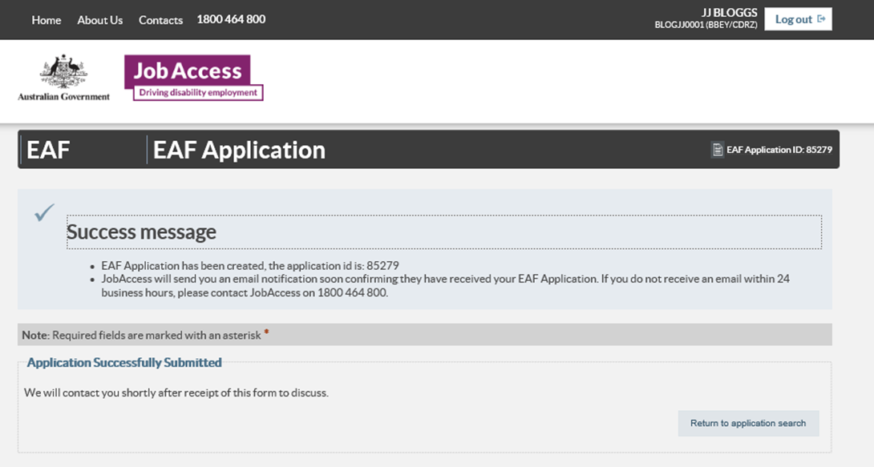
- If you do not receive a ‘Success message’ with an application ID number, please contact JobAccess on 1800 464 800 as your application did not save correctly
Please do not order or purchase any items prior to receiving written approval, as JobAccess is unable to make any retrospective payments.
The EAF is a reimbursement fund and JobAccess can only reimburse approved applicants after you have supplied proof of purchase. Directions for claiming reimbursement can be found in the EAF Guidelines, as well as the EAF approval letter sent on approval of the application.

