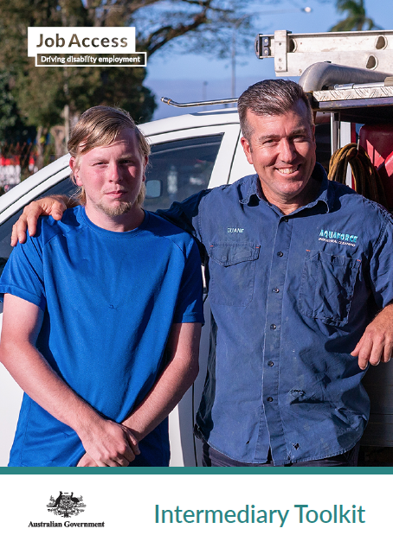

Toolkit: encouraging SMEs in open and inclusive employment
To assist organisations servicing small and medium enterprises
Job seekers living with disability make up a talent pool of people who are ready and willing to work with small and medium enterprises (SMEs). This toolkit is to help organisations who work with and support SMEs to promote the benefits of inclusive and open employment.
The success of JobAccess for medium to large enterprises has led the Australian Government to expand its resources. Support is available specifically for small to medium businesses to hire people with disability.
Your communication of these new resources to your networks will benefit businesses and job seekers.

Thank you for helping to bring employers and employees of all abilities together.

Help support SMEs and the community
Employing people with disability is good for businesses of all sizes. SMEs are at the heart of their communities and this initiative raises awareness of a talent pool that can help to fill skill shortages and boost local economies.
We know from research of SMEs that there’s a general desire among SMEs to employ people with disability, and when businesses do hire people with disability, experiences tend to be good. However, people with disability still experience unemployment at a much higher rate than other Australians.
We also know SMEs are time-poor and owners can wear many hats. While Government support and financial incentives are available to help SMEs employ a person with disability, many employers don’t know about these benefits and supports.
Promoting the supports available to SMEs through JobAccess will help save employers time and money running job ads, and your efforts will result in good outcomes for business and communities.
What you can do
Employers are already paying attention to your website, social media, newsletters and other channels.
We need your help to raise awareness of the supports available to SMEs when employing people with disability. Help us to promote these benefits and supports to SMEs by:
- Adding content to your website – we have provided a series of key messages and two infographics for use on websites and other promotions.
- Sharing posts and infographics on your social media – we have included a number of example posts which you can use on your social media.
- Distributing the fact sheet, case studies and JobAccess links amongst your SME networks.
- Holding an event for SMEs about the benefits of open and inclusive employment.
- Linking SMEs with JobAccess and the resources it provides whenever you can.
Who to contact
The Australian Government wants to make sure SMEs are aware of the supports available to them, and to help increase employment of people with disability in Australia. JobAccess is the Australian Government’s portal supporting businesses to employ people with disability.
We would love to hear about any promotions or events you undertake to help promote these resources and supports to SMEs. If you have an event or promotion to share, or need help with using this toolkit, contact us at:
JobAccess
Phone 1800 464 800 or https://www.jobaccess.gov.au/contacts
What is in this Toolkit
The following pages overview the resources included in the toolkit. These resources are packaged in the accompanying folder, including:
- Infographics - A4
- Key messages
- Links to JobAccess information and resources
- Social media post images and copy
- Case studies

Two infographics have been developed to provide quick and clear information in an easy-to-read and visual style. These infographics represent benefits of employing people with disabilities to SMEs (financial and social) and explains help and incentives available and how to access. These can be shared with intermediaries and published on the Job Access website. Infographics can also be provided to disability advocates and shared on social media.

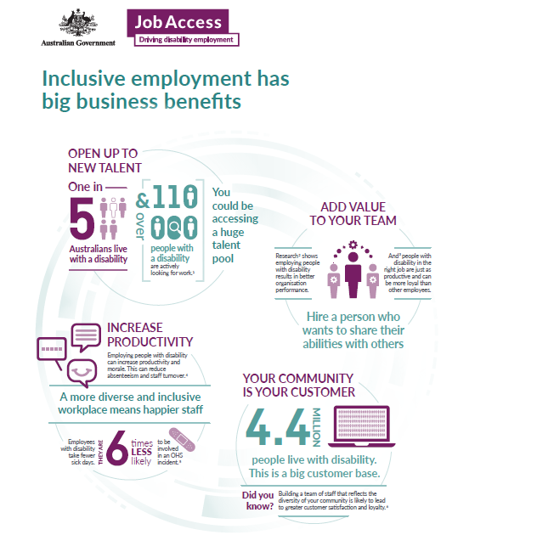

References
- https://www.abs.gov.au/statistics/health/disability/disability-ageing-and-carers-australia-summary-findings/latest-release
- https://content.iospress.com/articles/journal-of-vocational-rehabilitation/jvr00165
3. (Graffam, J, Shinkfield, A, Smith, K, and Polzin, U 2002, ‘Employer benefits and costs of employing a person with a disability’, Journal of Vocational
Rehabilitation, vol. 17, pp. 251-263.)
4. https://www.cciq.com.au/assets/Documents/Advocacy/Employ-Outside-the-Box-People-with-a-disabilityCCIQWeb.pdf
5. https://www.cciq.com.au/assets/Documents/Advocacy/Employ-Outside-the-Box- People-with-a-disabilityCCIQWeb.pdf
6. https://www.abs.gov.au/statistics/health/disability/disability-ageing-and-carers- australia-summary-findings/latest-release

DOWNLOAD

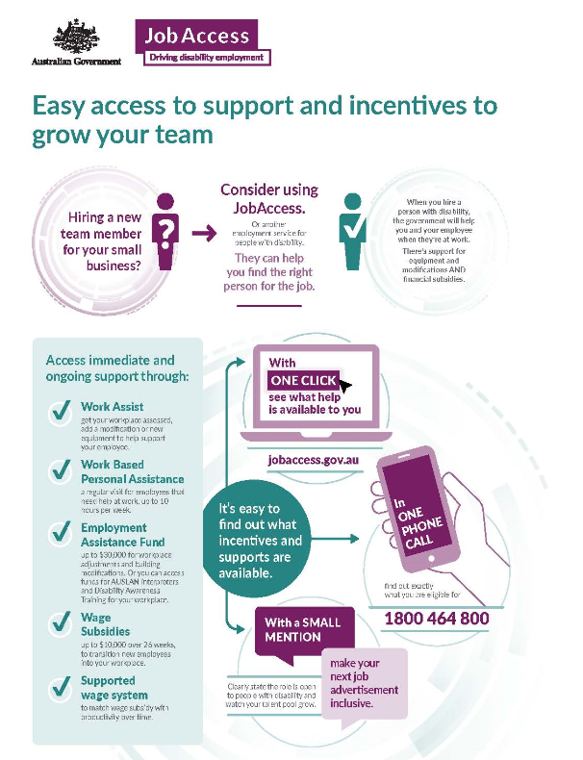

References
- https://www.jobaccess.gov.au/employment-assistance-fund-eaf
- https://www.jobaccess.gov.au/employers/wages-based-productivity

Web Banner
The below web banner has been designed as an online digital ad.

Key Messages for Intermediaries
Top line - General messaging for all applications
- Hiring a new employee? The right person for the job might be a person with disability.
- Having a recruitment process that is inclusive of people with disability is simple, effective and important.
- There is a large, talented pool of candidates with disability who are reliable and ready to work.
- Tailored support and employment services can help you hire the right person, saving time and money.
- A diverse and inclusive business is more competitive.
Raise awareness
“It’s easier than you think.”
Increase awareness among SMEs of the supports available to them when employing people with disability, specifically through JobAccess.
- Hiring a person with disability is rewarding and helps improve team culture.
- It’s easy to open up your recruitment process to be as inclusive as possible.
- Resources and advice are available to help you employ and support people with disability.
- There’s funding available to help make your workplace ready.
- You can access tools for small to medium-sized businesses online and contact JobAccess for personalised support.
“It’s good for business.”
Increase awareness of the benefits of employing people with disability.
- People with disability are proven to be reliable and productive employees across industries.
- People with disability are talented and able. There’s someone with the right skills to benefit your business.
- By up-skilling staff members with disability, you’re growing your business’ capacity and capability. It’s good for business and for your community.
- Businesses that hire people with disability report better profits and a have happier team.

Inspire and explain
“What’s in it for me?”

Increase likelihood of SMEs considering and being open to employing people with disability (including using inclusive recruitment processes).
- Hiring a person with disability is rewarding and helps improve team culture.
- Hiring a person with disability could lead you to the best person for the job.
- You can access grants and financial incentives to assist.
- Having a person with disability on staff will help you connect with a broader customer-base.
- You’ll be able to implement a person with disability’s unique perspective into your products and services.
- Being seen as an inclusive employer is good for business.
Ready and empower
“How do I start/what help’s available?”
Build confidence in SMEs who are open to employing a person with disability by ensuring there is easy, clear and accessible information available about supports.
- Step-by-step support is available to help you hire and retain a person with disability.
- Ensuring your recruitment process is inclusive of people with disability is easy to do.
- The JobAccess Employer Toolkit has everything you need to get started as a small to medium- sized business looking to hire a person with disability.
- Incentives and support are easy to access.
- There are Disability Employment Services to help you find job-ready candidates, with end-to- end recruitment services, at no cost.
- By using the available support, you will employ the best person for the job.
Adopt and commit
“Contributing to employment and benefitting”
Promote inclusive, open employment among SMEs, to encourage more SMEs to demonstrate a commitment to employing people with disability, and sharing in the benefits.
- Businesses from every industry are benefiting from hiring people with disability.
- Teams are stronger and workplaces are richer when they include members with different abilities.
- Join others in improving the diversity and strength of Australian business.

Key Messages for DES Provider
- Consider small to medium-sized businesses for your candidates.
- JobAccess now has a toolkit to help smaller businesses hire people with disability.
- At the moment, our local businesses are missing out on a big part of the talent pool.
- Small and medium-sized businesses find it difficult to seek reliable employees.
- They are often locally-based and easier for clients to access.
- They may not currently have the information about the support and incentives available to employ people with disability.
- This is an opportunity to expand your clients’ employment options.
- By placing more people with disability in small and medium-sized businesses, you’ll change local business hiring practices for the better.
- You’ll help local businesses to be more inclusive and diverse.
- This will lead to an increase in skills and employment opportunities for people with disability.

Links to JobAccess Resources
Disability employment basics
- What does disability mean?
What does disability mean, and how does it impact a person’s ability to work? Everyone’s experience of disability is different, so it’s important to focus on the individual.
- Diversity makes good business sense
Diversity and inclusion at work matters – and hiring people with disability is a big part of that. Find out why you should employ people with disability and the benefits it can have.
- Using inclusive language
The way we communicate has a big impact on how well people with disability can integrate at work, and even in everyday life. Making sure we are being polite, respectful and considerate is key to building an inclusive workplace.
- Workplace modifications made easy
Sometimes when we hire people with disability adjustments need to be made. Find out about the different supports and services available through JobAccess to make these changes.
Fundamentals for organisations
- Best practice policies and procedures
Understanding policies and procedures and what discrimination looks like is an important step towards an inclusive workplace.
- Advice and support for employers
When creating policies, procedures and hiring people with disability – you are not alone. There is a range of support available for recruitment, adjustments, training and more.
Recruiting people with disability
- Design and advertise your job
Once you are open to hiring people with disability, you need to know how to design and advertise job positions so that people with disability are encouraged to apply.
- Interview and selection process
Interviewing people with disability for a job means understanding how to prepare the right questions, and knowing your role in the process.
- Successful and unsuccessful candidates
Whether you’ve selected a person with disability for the role or someone else, you need to know how to let them know the news and give constructive feedback.

Getting your workplace ready
- Employment Assistance Fund
The Employment Assistance Fund is a free government service available to help make modifications to the workplace as easily as possible.
- Making physical workplace adjustments
Sometimes physical adjustments need to be made to make sure people with disability have the same chance to work as effectively as anyone else.
- Sourcing assistive technology
Sometimes people with disability require assistive technology to complete their job to the best of their ability.
Managing your team
- Managing an employee with disability
Many people with disability won’t require any specific management or help, but some might. Find out how to create a supportive, open working environment for people with disability.
- Disability and awareness training for staff
When you hire people with disability, sometimes other team members will need help knowing what to do and say. Find out how to help them prepare.
- Flexible work arrangements
Flexible working arrangements can mean a number of things. Being open to the idea and understanding how to implement these arrangements can be a great benefit to any organisation.
- Celebrate achievements
Sharing your successes, challenges and stories

Social Media
The following are post visuals and copy suggestions for use on your own social media channels.

Facebook / Instagram
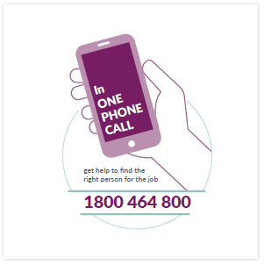
Your business, your clients and your community all benefit when you hire a person with disability. See how easy it is to find the right person for the job. Talk to a JobAccess provider free of charge:
1800 464 800
https://www.jobaccess.gov.au/employers

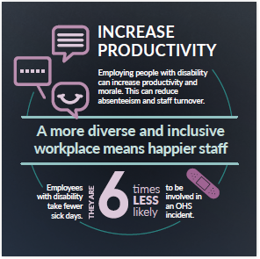
Diversity makes good business sense.
Businesses with diverse teams report higher profits and happier employees. You too can expand your customer base and improve your bottom line with inclusive hiring.
https://www.jobaccess.gov.au/node/77726

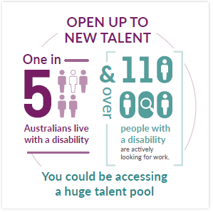
It’s easier than you think to be an inclusive employer. In fact, you’ll be supported and rewarded. If you need another team member, there is a big talent pool of people with different abilities who are job-ready. And there is immediate government support to help you hire.
Want to know more?
https://www.jobaccess.gov.au/employers/ benefits-employing-people-with-disability

Facebook / Instagram
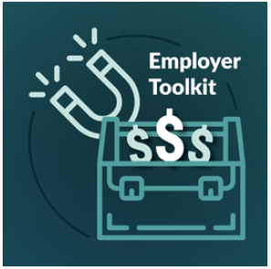
Customers are attracted to SME businesses who have diverse and inclusive teams. It’s easy to be one of those businesses with the help of the Employer Toolkit.
https://www.jobaccess.gov.au/employers/employer-toolkit

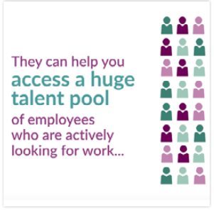
The different perspectives of a diverse team make your business more profitable. There are tools to help you hire the right person to grow your business and build your ideas factory at the JobAccess website.
https://www.jobaccess.gov.au/employers/employer-toolkit

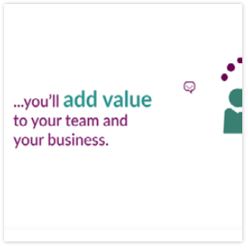
It’s proven that people with disability are responsible and productive employees across industries. A talented pool of candidates awaits. Contact your local Disability Employment Services provider
https://www.jobaccess.gov.au/employers/disability- employment-services-providers

Facebook / Instagram

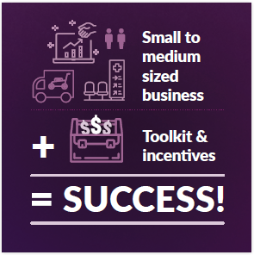
Are you a local business with 5 to 200 employees?
That makes you a small to medium-sized business. And it means you can take advantage of support and incentives to hire a diverse team of employees. The JobAccess website has a toolkit and info to get you started.
www.jobaccess.gov.au/employers/employer-toolkit

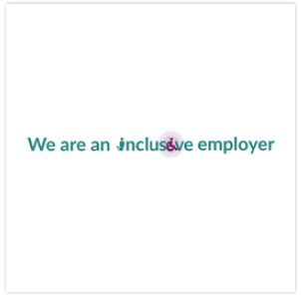
[INSERT] has a diverse and inclusive team. They said it’s made their small business stronger and more relevant in the community.
Draw on a skilled and talented pool of employees who have new ideas and the right skills for your business. You will receive ongoing support to do so through JobAccess.
To find out more, check out this toolkit designed to help you hire and retain staff living with disability. How does having a diverse team benefit your business?
www.jobaccess.gov.au/employers/employer-toolkit
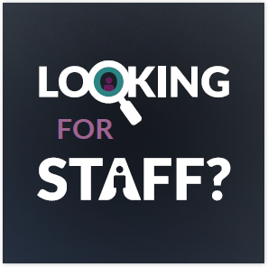

Having a team with different abilities is smart for business. Join other small to medium-sized businesses who are benefiting from workplace diversity with the help of JobAccess. You might also like to know about the available support and financial incentives on offer for your business.
www.jobaccess.gov.au/employers/available-support

LinkedIn Posts
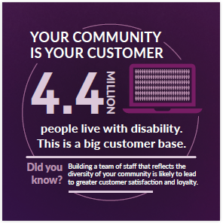
Rewards for being an inclusive employer
Are you an inclusive employer? Small and medium businesses that hire diverse teams are stronger and often report higher earnings.
If you are an inclusive employer, you already know all this. But did you know you can access tailored information and support as a small to medium business to employ people with disability? New tools are now available.
https://www.jobaccess.gov.au/employers/employer-toolkit

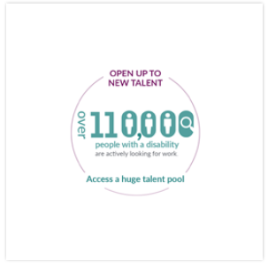
Employ the right person for the job: Employ Their Ability
Looking for a new team member? If you consider a person with disability, you’re opening up your search to a talent pool of people who are job-ready, have excellent skills and fresh perspectives. 1 in 5 Australians live with disability. That is a lot of people with a huge range
of skills. It’s a lack of exposure and understanding that can cause people with disability to be overlooked by employers.
Take the step now to make your next recruitment inclusive. Access the range of incentives and support to hire a person with disability. There is help for your business from the very start, and continuing throughout employment. You’ll be surprised at how simple it is to employ the right person. A diverse team is a stronger team.
https://www.jobaccess.gov.au/employers/employer-toolkit

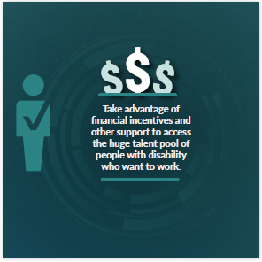
Support to help you hire a new employee
As a small to medium-sized business, it can be difficult to attract and retain staff. You’re probably already wearing a lot of hats, so being the HR Department on top of that is not easy. Take advantage of financial incentives and other support to access the huge talent pool of people with disability who want to work. Get personal help through the Australian Government’s JobAccess and Disability Employment Services.
You will end up with a job-ready employee who has the right attitude to help your business thrive. Your business will be better off for it.
Sound good? Find out more about the financial support available. https://www.jobaccess.gov.au/employers/ subsidised-wages-people-with-disability

Case Studies
The following are case studies of small to mediums enterprises that have shared their experiences employing a person with a disability.

Case Study

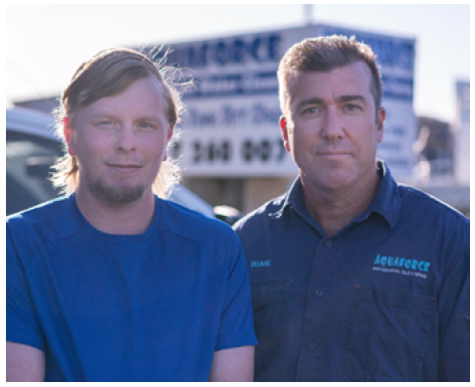
Aquaforce, Innisfail, QLD
Hiring a person with disability was the right choice for a Far North Queensland cleaning business looking to add to their six-person team.
Aquaforce Industrial Cleaning owner Duane Amos is glad he hired Jamie, who has turned out to be a top worker.
Jamie has Asperger’s syndrome and finds reading and writing challenging.

“It’s always been difficult through high school and looking for a job, because people don’t usually want to employ somebody with a disability,” Jamie said.
But Duane couldn’t be happier with Jamie’s work.
Duane wants to hang onto Jamie for as long as he can — giving him extra hours at every chance.
“We were told Jamie had Asperger’s syndrome and I said ‘I’m not interested in that. He does a day’s work and he gets a day’s pay’,” Duane said.
In his nine months with Aquaforce, Jamie has become an important team member — building skills and confidence, and taking on more responsibilities over time.
“Jamie is an asset to the business,” Duane said.
“From the start, Jamie has been dependable and ready to learn. He has never turned up for a shift less than half an hour early.”
Duane said it was easy to employ and induct a person with disability into the business.
“It’s just a matter of creating an environment
that works for both the employer and employee,” Duane said.
“We try and promote that adult learning environment: explanation, demonstration, then having a crack at it. Then more coaching and mentoring.
“Jamie now can ask for feedback. He’s open enough to say, ‘I’m not comfortable with that yet’.”
Duane and his wife Kathy started Aquaforce in Innisfail, Queensland more than a decade and a half ago — originally cleaning banana packing
sheds. The growth of their small business saw them expand into cleaning home and business exteriors, forensic areas, public facilities and solar panels.
As well as cleaning, Jamie preps and checks machines at the end of each work day. He does small system repairs and machine services, and is solely responsible for a regular contract with a local fast food restaurant.
“It made me feel happy that I’ve actually got a job and getting money in the bank. I don’t feel like I’m restricted,” Jamie said.
Duane hopes the skills he is passing on will give Jamie the chance to pursue his career goal to work in mechanics.
Help and financial support are available to small businesses to employ people with disability. Find out more at jobaccess.gov.au or phone 1800 464 800 to be put in contact with a service that can connect you with people who are ready to work.

Case Study
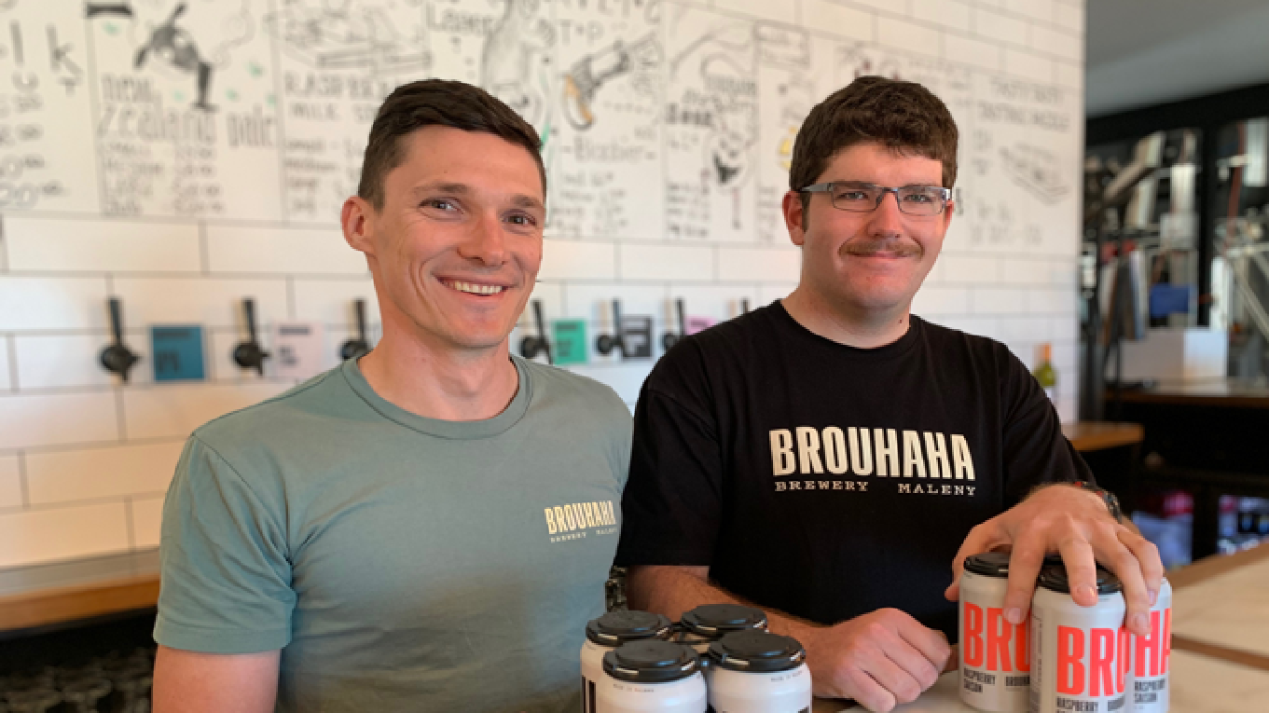

Brouhaha Brewery, QLD

Owning a brewery is a dream come true for Matt Jancauskas.
But he still faces the same challenges as any other small business owner, when it comes to finding the right employees.
“Through a food networking group, we heard about options to employ people through a Disability Employment Services provider — and we decided it would be worth looking in to,” Matt said.
Within a few short weeks Matt’s business, Brouhaha Brewery on the Sunshine Coast, was introduced to 22-year-old Mitch Blood – who has turned out to be a perfect match for one of the brewery’s most important roles.
“As a brewery, one of the most critical positions in the business belongs to the person on the canning and packing line,” Matt said.
“We’re canning on a small scale, so we don’t have high level machinery – instead we rely on highly
attentive humans. It’s one of the most important jobs we have when it comes to getting our product to market.
“We send our boutique beer all over Australia, so if there’s the slightest imperfection or smallest
defect on a can or pack of beer it can have massive repercussions for us.
“It could explode and be recalled … things can escalate pretty quick and cost a lot of money.”
For the brewery’s first three years in business, the canning line role was difficult to fill.
Then, Mitch arrived.
“Other people we’d put on the canning line had been consistently inconsistent,” Matt said.
“Mitch has Asperger’s and he is very careful about what he does — everything he does is done impeccably.
“His attention to detail is second to none and he works methodically and carefully. On the canning

Case Study (continued)

line it’s not about speed, it’s about consistency, and Mitch has delivered that to us in spades.”
Prior to starting work at the brewery, Mitch was working as a school cleaner, but found it wasn’t a good fit.
“I had to work so quickly to tick off everything that had to be done and often that meant I couldn’t do the job properly,” Mitch explained.
“Here at Brouhaha I’m rewarded for taking things at the correct pace to make sure I can do my job really well. That doesn’t mean I’m allowed to be slow though – we always aim to get as many cans safely and correctly on to the conveyor belt as possible in a day.
“My favourite thing about this job though is that I can be myself, and my best efforts are recognised. It makes me feel pretty good and I like working with a small team because it’s made getting to know and trust everyone heaps easier.”
Not only has Mitch filled a role Matt desperately needed done well — he’s also brought out the best in his fellow staff members.
“They’ve taken on extra responsibilities to help Mitch succeed, and that’s not something I’ve asked them to do,” Matt said.
“They’ve stepped up because they can see that Mitch is an asset to our whole team.
“Having Mitch working with us has made us all better people and better team members —which is a pretty cool thing, and that really helps foster a great working environment.”
Matt said he wishes he’d considered employing a person with a disability sooner.
“As a small business owner, I assumed it would be too difficult, to be honest,” Matt said.
“I don’t know why I had that perception. But for me, it felt like something that only larger companies would have the time to facilitate properly or afford to do.
“That couldn’t be further from the truth, because it’s actually really easy and I wish I’d looked in to when I first started the brewery.
“We’re well supported through our Disability Employment Services provider and we’re so grateful to them for connecting us to Mitch, and he’s happy to have a job he enjoys.
“Mitch clocks on and off like every other employee.
He’s always here a little bit early, eager to start his shift and he doesn’t go home until he’s happy everything is in order.”
In just a few short months at the brewery, Matt said Mitch has become more confident.
“He actually came to the brewery for lunch with his family the other day and he was so proud to show them around and introduce his Mum to different staff members,” Matt said.
“He even bought a four-pack of beer to give to a friend as a gift who had helped fix his car.
“So he’s actively out there supporting our brand too! It’s a great story to be a part of.”
Help and financial support are available to small businesses to employ people with disability. Find out more at jobaccess.gov.au or phone 1800 464 800 to be put in contact with a service that can connect you with people who are ready to work.

