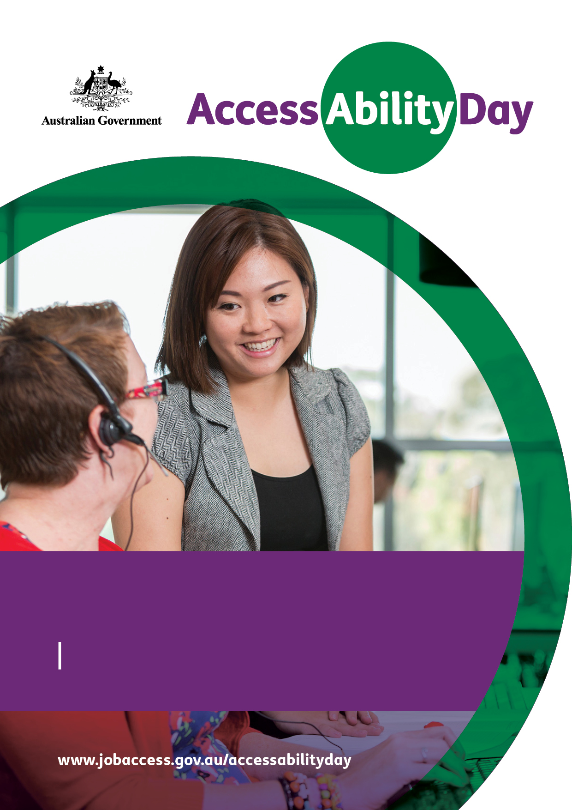
A how to guide
For employers
AccessAbility Day
Connecting jobseekers with disability and employers to explore new possibilities in the workplace for one day during the week Monday 26 to Friday 30 November 2018.

Open your door
To a new pool of talented and capable individuals, who are ready and willing to work.

No obligation
Just an exciting opportunity to see what a jobseeker with a disability has to offer.

Supported by
Your local Disability Employment Services (DES) provider.

More information
Visit the AccessAbility Day website
www.jobaccess.gov.au/accessabilityday
Phone 1800 464 800
TTY users please phone 1800 555 677 and ask for 1800 464 800

What is AccessAbility Day? 4
How can employers get involved? 4
What is the role of Disability Employment Services? 4
What is the role of JobAccess? 5
Success Story 6
What will happen on AccessAbility Day? 6
How do employers register for AccessAbility Day? 8
How is the employer matched to a jobseeker? 8
Insurance 9
Before AccessAbility Day 9
Checklist 10
Quick guide for employers 11
Promoting AccessAbility Day 12
Disability and employment 12
Disability employment in Australia 12
JobAccess 13
The National Disability Recruitment Coordinator 14
Contents

What is AccessAbility Day?
AccessAbility Day is an Australian Government initiative, connecting jobseekers with disability and employers for a one day opportunity to:
- learn more about working with jobseekers with disability
- promote and encourage an inclusive workplace
- access a talent pool of capable people who are keen to work
- learn more about free disability employment services and support available for employers.
The initiative will be available from Monday 26 to Friday 30 November 2018, in the week leading up to the annual United Nation’s International Day of People with Disability on 3 December.

How can employers get involved?
Employers can host a jobseeker with disability (a participant) for one day in the week from Monday 26 to Friday 30 November 2018.
An employer can host as many participants across as many job types as they are able to provide within their organisation. However, each participant can only be placed in each workplace for one day.
AccessAbility Day is not a job interview, work trial or work experience. It is a job shadowing opportunity for the participant to try a day in a workplace and see what the workplace has to offer. It is also an opportunity for the employer to learn more about working with jobseekers with disability.
There is no obligation to employ the participant after the placement.
This is a wonderful opportunity to allow the jobseeker to gain insight into a particular job or type of work.

What is the role of Disability Employment Services?
Disability Employment Services (DES) is the Australian Government’s employment service that helps jobseekers with disability find employment and keep a job. DES providers are a mix of large, medium and small, for-profit and not-for-profit organisations that support jobseekers with disability by connecting them with prospective employers.
Your local DES provider will work with you to match your workplace to a potential jobseeker on one day during AccessAbility Day.
All jobseekers participating in AccessAbility Day are required to be current and active DES participants, looking for work, as this ensures they are covered by government provided insurance at no cost to you.
Jobseekers registered with DES may have an injury or health condition that requires occasional support, or a permanent disability that requires ongoing support, in the workplace.
To find out more information about the types of disability that job seekers may disclose visit:
- Disability and Adjustment on the JobAccess website
- Disability Employment Services on the Department of Human Services
- Eligibility, Referral and Commencement Guidelines on the Department of Social Services website

What is the role of JobAccess?
JobAccess is funded by the Australian Government to provide information, tools and resources for jobseekers with disability, employment service providers and employers about employing people with disability in the workplace. JobAccess’ involvement in AccessAbility includes:
- AccessAbility Day webpages hosted on the JobAccess website with information and resource including registration for employers new to working with DES
- a dedicated hotline and mailbox providing information on AccessAbility Day and directing callers to appropriate resources
- engagement with employers new to working with jobseekers with disability to encourage them to participate in AccessAbility Day

Success Story
Michael Gower, Belgravia Leisure, Elizabeth South Australia
At Belgravia Leisure, we believe that working together with our communities plays a critical role in creating positive social impact. Just over two years ago, we teamed up with a local Disability Employment Services (DES) provider to ensure we were a truly equal opportunity employer.
At first, I was apprehensive of the requirements to meet accessibility needs of potential staff, simply because I was unaware of what they were. Our DES provider provided valuable insight and guidance; I learned a lot through the process. By working together modifications were, and continue to be, made and we have since brought on several people with disability into long-term employment.
Participating in AccessAbility Day has been a great opportunity to provide a workplace experience in the recreation and sports industry. We hosted multiple placements at Genesis Fitness and Little Para Golf Course.
At Little Para Golf Course, participants teamed with staff, who also have a disability, to learn about retail and customer service aspects in the pro shop, work health and safety, and operational tasks like ball collection and running the course and driving range.
I highly encourage interested employers to speak with their local DES provider to learn more about bringing a person with disability onto their team.

What will happen on AccessAbility Day?
Everyone’s AccessAbility Day experience will be different. It will depend on your workplace and the specific skills and interests of the participant.
Some of the activities may include:
- a meet and greet, where the participant is introduced to staff members
- a tour of the workplace to familiarise the participant with the location, environment and facilities (i.e. bathroom, kitchen, etc.)
- a rundown of Work Health and Safety requirements and security and evacuation procedures
- a demonstration of the industry specific skills of your employees
- a discussion about why you became involved in AccessAbility Day
- providing an opportunity for the participant to observe an employee in the workplace and encourage them to ask questions
- explaining the mission and goals of your organisation
- asking your employees to share their career path and experiences with the participant. For example, how long they have worked at the organisation, their skills and qualifications, possible career paths within the organisation, the benefits of working at the organisation
- discussing your participant’s career interests, experience and goals
- scheduled check points throughout the day so the participant can ask questions or ask clarification on what they’ve experienced so far
- a reference for the participant to add to their Curriculum Vitae (CV). This is recommended as best practice.
It is important that the participant has access to breaks during the day similar to those taken by other employees in the workplace, or as they need and agree with you.
Participants should be made to feel welcome in your workplace. If the participant uses a wheelchair or walking aids, or has a hearing or sight impairment, it may be necessary to make some reasonable adjustments to your workplace such as ensuring the corridor is clear of obstacles, and using wheelchair accessible offices and meeting rooms.
Participants who are deaf or have a hearing impairment may be able to access Auslan Level 2 interpreter services through the Employment Assistance Fund (EAF) and be accompanied by an Auslan interpreter in your workplace.
If the participant has disclosed mental health issues, your organisation should be aware of ways to accommodate individual needs. People with a diagnosed mental illness are likely to be aware of the stressors that can trigger symptoms of their illness.
Your local DES provider who facilitated the placement will be able to advise you on how to make simple accommodations for participants.
You can also call the dedicated AccessAbility Day contact centre for advice on 1800 464 800. TTY users please phone 1800 555 677 and ask for 1800 464 800.
Employers will also need to understand any needs or special requirements that your AccessAbility Day participant may have agreed to disclose to their DES provider and to you as a host employer.

How do employers register for AccessAbility Day?
Registration is straightforward and hassle-free.
If you are not already involved with a DES provider, simply complete the online registration form at www.jobaccess.gov.au/accessabilityday to register your interest to host an AccessAbility Day placement. You will be matched to a DES provider in your area with an interested participant.
If you are already involved with DES, contact your DES provider directly to let them know you interested in participating in AccessAbility Day. A DES provider may also contact you directly.
There is no need for employers with an existing DES provider relationship to register online.
Registrations close on Tuesday 20 November 2018.

How is the employer matched to a jobseeker?
If you are an employer not already involved with a DES provider, when you register online you will be contacted by one or more DES providers in your local area, who have a current and active DES jobseeker with an interest in participating in AccessAbility Day, based on the type of role or placement type/s that you have registered.
Employers already involved with DES can work directly with their current provider to organise AccessAbility Day placements.
Your DES provider will work with you and the participant to organise a mutually suitable date for the AccessAbility Day placement during the week Monday 26 to Friday 30 November 2018.
Your DES provider will provide you with information on the participant who will be placed in your workplace. This may include their name, interests and any simple and free workplace adjustments you can make, taking into account the individual and their specific disability accessibility requirements. Please treat this information confidentially, as you would for any of your employees. Please note that funding for workplace modifications is not included in AccessAbility day, and modifications are not expected to be funded by the employer, however you may be eligible to access Auslan services for your participating jobseeker. You can discuss this with the DES provider.
It is important to keep in contact with your DES provider and let them know if your contact details change at any time. Your DES provider is best placed to confirm details of your placement and provide information on the participant who will be placed in your workplace.
For any questions on AccessAbility Day in general or tips on how to best work with jobseekers with disability contact the AccessAbility Day hotline on 1800 464 800. TTY users please phone 1800 555 677 and ask for 1800 464 800.

Insurance
The Department of Social Services purchases personal accident insurance and combined public and product liability insurance to cover participants undertaking Activities, including AccessAbility Day placements (for example travel to and from the location).
Your DES provider is able to provide you with further information on the insurance policies and what to do in the case of any accidental damage or injury.

Before AccessAbility Day
Being prepared is the key to a successful AccessAbility Day experience. It is recommended that you:
- communicate expectations with the DES provider including the expected dress code, personal protective equipment (PPE) if appropriate and if the participant is required to bring anything to the workplace
- confirm the meeting place, time and contact person on the day for the participant with the DES provider, including parking and drop-off information
- let your employees know that you will being hosting AccessAbility Day placement(s)
- consider scheduling a team meeting on that day to welcome your participant
- have an understanding of any needs or special requirements that your AccessAbility Day participant may have agreed to disclose to their DES provider.

Checklist
Activity | Completed
Register your interest at www.jobaccess.gov.au/accessabilityday or let your DES provider(s) know that you are interested in participating in AccessAbility Day
Your DES provider has discussed your available AccessAbility Day placement/s with you
Confirmation received that a participant has been allocated to your workplace
Inform your DES provider of any participant requirements including arrival time, contact details, dress requirements if applicable
Consider and plan activities for the AccessAbility Day participant
Print out posters from the website to put up at your workplace
Market and promote your involvement in AccessAbility on your website and through your social media channels
Participate in AccessAbility Day

Quick guide for employers
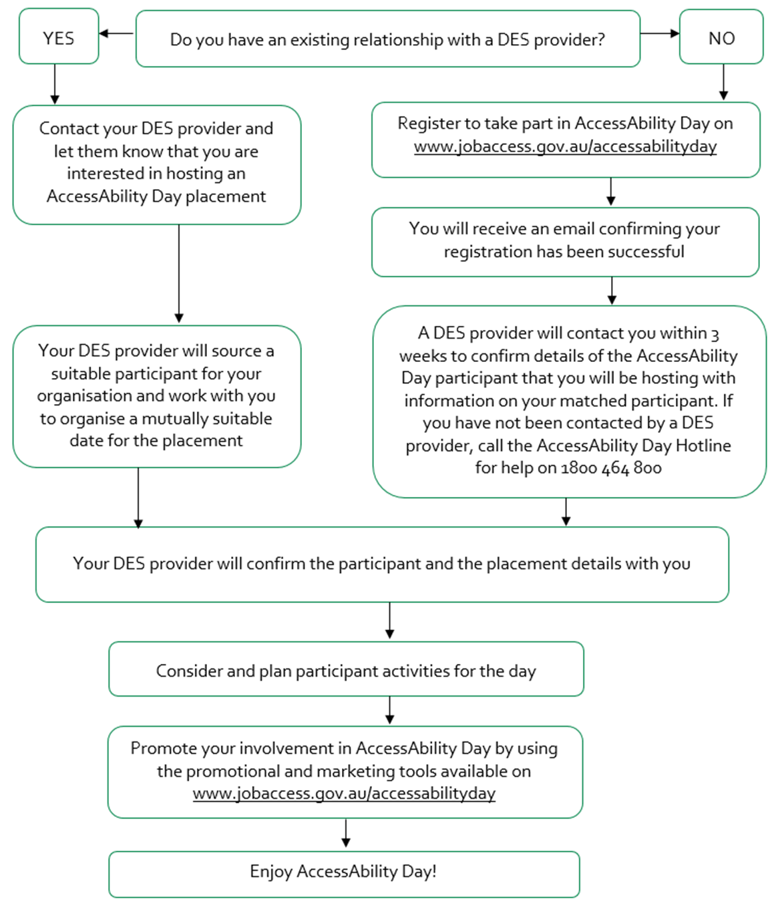

Promoting AccessAbility Day
You are encouraged to promote your involvement in AccessAbility Day to your employees, stakeholders and customers. You may wish to consider:
- internal communications (for example, emails or newsletters)
- social media posts
- linking to the AccessAbility Day website on your website
- using the hashtag #AccessAbilityDay
There are a number of promotional items available on the AccessAbility Day website at www.jobaccess.gov.au/accessabilityday. These include printable posters and flyers and online promotion tools such as a web badge and social media images.
You should seek written and informed consent before photographing or videoing anyone involved in AccessAbility Day.

Disability and employment
Disability is part of human diversity. There are more than four million people in Australia living with disability. Some people are born with disability, while others acquire disability with age or accident. Disability may be visible or hidden, permanent or temporary and may have a minimal or substantial impact on a person’s abilities. No two people will experience disability in the same way.

Disability employment in Australia
According to the Australian Bureau of Statistics (ABS), in Australia in 2015, over one million working-age people with disability were in paid employment, comprising 8.8 per cent of the total Australian workforce.
However, only 53.4 per cent of working age people with disability are in the labour force, compared to 83.2 per cent of people with no disability. Almost one-third of the people with disability who were working part-time wanted to work more hours. One in seven unemployed people with disability reported they need supports or special arrangements at work. The most commonly reported support arrangements are allocating different duties and training or retraining.
Like all employees, people with disability bring a different perspective and a range of skills, abilities and qualifications to the workplace and work in all sorts of jobs. Australian and international studies have also shown people with disability to be reliable and productive employees, with lower insurance cover and compensation costs.
Disability is an umbrella term, covering impairments, activity limitations and participation restrictions. People with physical, sensory, speech, cognitive, mental health and other impairments experience unintended barriers, when participating in society (including employment).
Source: World Health Organization definition of disability
The vast majority of people with disability can and do work with great benefit to themselves, their organisation, the community and the economy. In fact, it’s likely that you’re already employing someone with disability, as most do not require any changes to the workplace.
- Too often, stereotyping is a key reason why people with disability are not considered for jobs.
- Being open minded is a great start to increasing awareness of disability and employment.
- Exposure can build confidence and reduce doubts.
- Acknowledge that labelling a person only reinforces stereotypes and limits opportunities.
- Put simply, employing people with disability can make good business sense.

JobAccess
In addition to supporting AccessAbility Day, JobAccess plays a vital role in bringing together information and resources that ‘drive disability employment’.
This free service exists to help remove barriers to disability employment by providing:
- an advice and information service delivering expert and confidential assistance with all matters of disability employment
- a comprehensive website – www.jobaccess.gov.au – with a wide range of disability employment resources, tools and links to available support services
- access to the Employment Assistance Fund by co-ordinating funding for reasonable workplace adjustments, modifications and training that enable people with disability to do their job
- an Employer engagement service called the National Disability Recruitment Coordinator that assists employers to build disability confidence and competence
- vital reporting services including the Complaints Resolution and Referral Service and National Disability Abuse and Neglect Hotline.

The National Disability Recruitment Coordinator
The National Disability Recruitment Coordinator (NDRC) is the employer engagement service of JobAccess. The NDRC is designed to help employers access the skills and talents of people with disability. The NDRC can work with you to develop workplace policies and practices that accommodate people with disability. As well as providing a comprehensive job vacancy service, the NDRC conducts workplace training and employer seminars on disability awareness.
Contact a JobAccess Adviser on 1800 464 800 and they can connect you to the NDRC.
AccessAbility Day is a one day commitment. More information about working with people with disability, available free Government support, and advice is available through JobAccess.
For employers, Disability Employment Services can provide a range of free services, including help to employ and retain workers with disability and access to a range of financial incentives and support.
When a person with disability has been placed in a job, a Disability Employment Services provider will give them employment support for at least 52 weeks. Support can also be provided to help both the employee and employer beyond this time, where it is needed.

