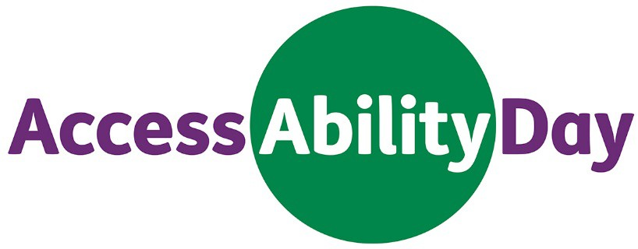

Connecting employers and people with disability

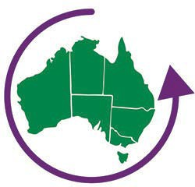
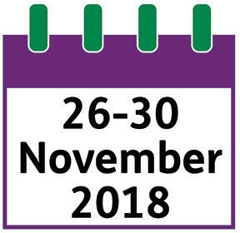
Information for people with disability AccessAbility Day

AccessAbility Day is about helping people with disability learn more about the kind of job they want.
It will be held all around Australia.
You can take part in AccessAbility Day on any day between 26 and 30 November 2018.

If you take part in AccessAbility Day you can:
- talk to a Disability Employment Services (DES) provider about new jobs
- visit a new workplace for a day
- learn about different kinds of work
- meet other people in the workplace and employers
- make new friends and connections.
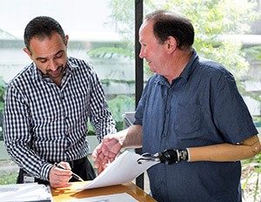

If you want to take part in AccessAbility Day, you will need to:
- be registered as looking for work with a DES provider
- tell your DES provider you want to take part in AccessAbility Day.
Your DES provider will:
- talk to you about your interests
- find the right AccessAbility Day employer to host you for the day.
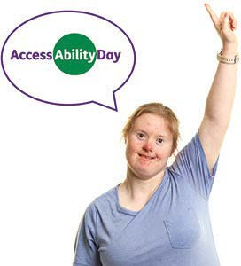
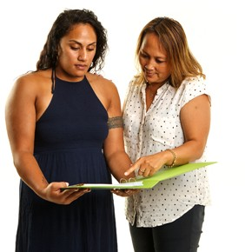

If you want to know more you can:
- Call 1800 464 800, or

- Speak to your local DES provider
If you use a TTY phone, call 1800 555 677
and then ask for 1800 464 800.
Let’s work together.
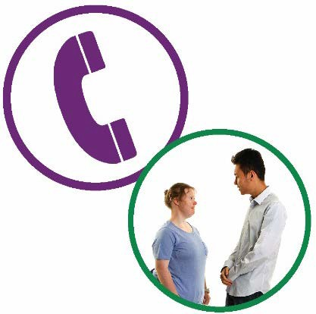
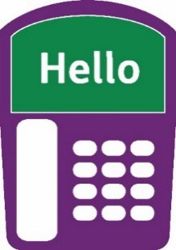
This Easy Read document was created by the Information Access Group using stock photography and custom images.
The images may not be reused without permission. For any enquiries about the images, please visit www.informationaccessgroup.com.
Quote job number 2924.

