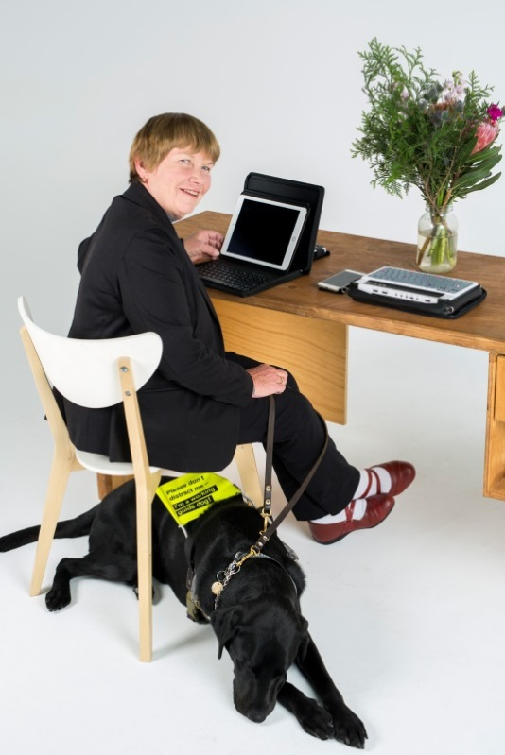
Available services and programmes for people with disability
There are many services and programmes available to people with disability to help them get ready for, find and keep a job. These include:
Wage Subsidies give potential employers added incentive to hire people with disability.
Work Based Personal Assistance can help pay the costs of workplace support services for people who need regular help due to their disability or medical condition.
Mobility Allowance can help you cover the costs of travelling to and from work, study, training, volunteering or looking for work if you are unable to use public transport.
The Relocation Assistance to Take Up a Job programme can help reimburse your relocation costs.
Personal Helpers and Mentors Employment Services can help you if your life is severely affected by mental illness, you are receiving eligible income support, and you are required to find a job.
Work Assist is available if you are at risk of losing your job as a result of your disability, injury or health condition.
New Enterprise Incentive Scheme can help if you want to run a new small business.
National Work Experience Programme can help if you are interested in doing paid or unpaid work experience to help you gain on-the-job skills and confidence.
Community Development Programme helps people get ready for work and find jobs in remote Australia.
Skills for Education and Employment can help improve your speaking, reading, writing or basic maths skills.

JobAccess is the national hub for workplace and employment information for people with disability, employers and service providers.

1800 464 800 www.jobaccess.gov.au
About Disability Employment Services V.1.0 1890.06.16

