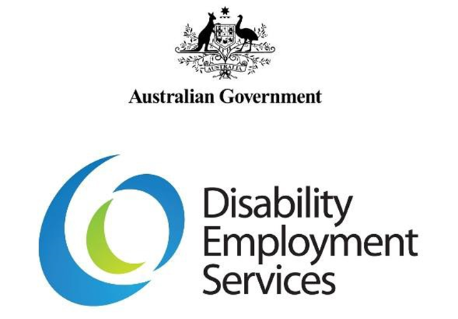

OVERVIEW OF THE SUPPORTED WAGE SYSTEM UNDER THE SUPPORTED EMPLOYMENT SERVICES AWARD

July 2018

Disclaimer
This Overview is written specifically for use of the Supported Wage System under the Supported Employment Services Award. This Overview provides brief information only, and should be read in conjunction with the Supported Wage Handbook and Guidelines.

Overview – How to use the Supported Wage System

Introduction
The Supported Wage System (SWS) productivity assessment process provides a method to assess the productivity of the employee against performance standards of other employees with or without disability undertaking the same tasks or duties in the workplace.
This Overview applies to SWS used to determine productivity based wages for employees employed under the Supported Employment Service Award 2010 (SES Award). In 2017, industrial parties in the Fair Work Commission (FWC) agreed by consent to vary the SWS for use under the SES Award. There is a separate Overview document for use of the SWS in open employment.

Eligibility
Applications for the SWS require that the following conditions are met:
- the job under consideration is covered by the SES Award
- the person is an Australian citizen or is a person resident in Australia whose continued presence is not subject to a time limit imposed by Commonwealth law (e.g. a temporary visa)
- the person is at least 15 years of age
- the person has no outstanding workers’ compensation claim against the current employer
- the person meets the impairment criteria for the Disability Support Pension (DSP) as determined by Centrelink
- the job being offered is for a minimum of 8 hours per week.
The SWS procedures apply whether a person is registered with an employment services Provider or not. A summary of the key steps in the wage assessment process are described later in this section.
The procedures assume the employee is currently receiving the DSP. However, if the person is not in receipt of the DSP, Centrelink may need to arrange an SWS Eligibility Test. Variations to the process for people who do not receive the DSP are detailed at the end of this section.

Contacting the Department’s Assessment Team
The Department of Social Services’ (the Department) Assessment Team can be contacted by phone for general information on the SWS. The phone number is 1800 065 123.

Making the application
The on-line SWS application form is available on the JobAccess website and is completed on-line. Many people with disability are clients of employment services Providers, who can help facilitate the application for SWS. However, people who are not registered with an employment services Provider may also apply for SWS.

Processing the application
The Department’s Assessment Team:
- confirms the employee meets the impairment criteria (the Department’s Assessment Team may contact Centrelink to confirm this)
- checks the other eligibility criteria have been met
- approves or declines the application.

Advice of approval
The Department’s Assessment Team sends advice of an approval to the applicant. Once this approval has been given, the employee can commence the SWS Trial Period.

An assessment is arranged
- the Department’s IT system generates and issues a Work Order to a contracted SWS Provider
- the Provider accepts the Work Order and arranges for an approved SWS assessor to make arrangements for the assessment.

Work begins on a trial basis
After the application is approved, the employer and employee or nominee negotiates a trial wage. The trial wage must be at least the Federal minimum SWS hourly rate, and should ideally reflect the expected productivity levels for the Trial Period.
Employees covered by the SES Award under SWS provisions must be paid a minimum hourly wage rate. This rate of pay is to be the higher of:
- the assessed productive capacity of the employee rounded to the nearest whole percentile
or
- 12.5 percent of the Award wage if the assessed productive capacity of the employee is less than 12.5 percent.
The SWS Trial Period can only start once the SWS application has been approved by the Department’s Assessment Team. The Trial Period must be a minimum of 13 weeks and a maximum of 26 weeks. The extension of the Trial Period is only acceptable when it is for the benefit of the employee, such as due to absence from work because of illness or where it is expected that the person could further improve work performance in a short period.

Advising Centrelink of change in financial circumstances of a person in receipt of DSP
Centrelink requires advice about the SWS employee’s wage during the Trial Period, and any subsequent wage adjustments. The employment services provider may assist the employee to advise Centrelink. It is important to advise Centrelink within 14 days in case the employee’s earnings affect the rate of DSP. More information can be found on the Department of Human Services website.

The lead up to the assessment
Following receipt of a Work Order, the assessor negotiates a suitable date and time with the workplace parties for the assessment to take place. Workplace parties could include the employer, assessor, employee or nominee, and union representative (if applicable).

After the assessment
After the assessment result is agreed, the workplace parties sign the Wage Assessment Agreement. If a union representative was not party to the Wage Assessment Agreement, the Fair Work Commission sends a copy of the Wage Assessment Agreement to the relevant union. If the union has not notified an objection to the industrial authority within 10 working days, the Fair Work Commission then advises the employer and the Department’s Assessment Team that the Wage Assessment Agreement has been filed successfully.
The assessor always provides a copy of the Wage Assessment Agreement to the workplace parties as soon as is practicable.

The date for beginning to pay the assessed wage
The date when the employer can legally pay the agreed pro-rata award wage is the date when the Wage Assessment Agreement is signed. The employer pays the agreed wage rate from this date, and does not have to wait until notification has been received from the Fair Work Commission that the Wage Assessment Agreement has been filed.

Review assessment
Reviews will be undertaken one year after the initial assessment and subsequently within a period not exceeding three years’ service with the employer since the previous assessment.
A review may be held before the scheduled date if at least one of the workplace parties wishes this to occur. This can be requested by contacting the Department’s Assessment Team.

Variation in procedures for people who are NOT receiving the DSP
A person not receiving the DSP may choose:
- to claim the DSP, or
- not to claim a payment, but only to test whether they meet the medical impairment criteria for the DSP. This is referred to as an SWS Eligibility Test.
If the person chooses to apply for the DSP, it is advisable that they obtain information from Centrelink about the claim process. More information can be found on the Department of Human Services website.
For a person not on the DSP, the Department’s Assessment Team arranges an SWS Eligibility Test by contacting Centrelink. Centrelink will contact the person to arrange an assessment for the SWS Eligibility Test.
If the person is assessed by Centrelink as meeting the SWS Eligibility Test, the Department’s Assessment Team processes the SWS application.

Summary of the SWS Process – Key Steps
- Access the JobAccess website or phone the Department’s Assessment Team (free call 1800 065 123) for information.
- Complete and lodge the application form on the JobAccess website.
- The Department’s Assessment Team checks the employee’s eligibility.
- If the employee is not in receipt of the DSP and does not have a current medical impairment assessment then the Department’s Assessment Team contacts Centrelink to arrange for an SWS Eligibility Test.
- If the employee meets the DPS criteria, then the Department’s Assessment Team approves the application and a confirmation email is sent to the applicant.
- The employee commences the Trial Period.
- The SWS IT System assigns the assessment to an SWS assessment provider.
- If the employee is on income support, the employee notifies Centrelink about the employment.
- The SWS wage assessment is conducted and agreed, and lodged with the Fair Work Commission.
- The SWS IT system automatically initiates annual productivity reviews thereafter. The Department’s Assessment Team can arrange an earlier review if requested.

