Funding available for people with disability
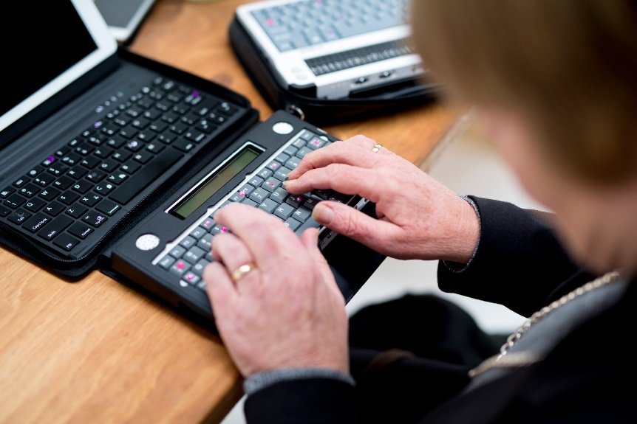
As a person with disability you may be able to access the Employment Assistance Fund (EAF) to pay for workplace modifications and equipment that you need to do your job.
The EAF can assist you if you are about to start a job, are already employed, or are self-employed if you meet the eligibility requirements.
If you are a job seeker who requires Auslan Level 2 assistance or who requires work-related assistive technology or special work equipment to look for and prepare for a job, EAF may also be able to assist you.
Some of the things the EAF can be used to pay for are:
- workplace modifications and equipment, such as alternative lighting, building modifications to make toilets accessible, access ramps, assistive technology, adapted appliances, electronic and communication equipment
- modification to work vehicles, if the use of the vehicle is part of your essential job requirements
- communication technology devices, such as paging systems, Braille printers, assistive listening devices and alert systems for telephone, doors and fire alarms
- Auslan (Australian Sign Language) interpreting services for work related activities, including for job interviews
- special computer software and software upgrades (i.e. screen reading and speech recognition software)
- specialised support for people with mental health conditions or learning disorders; and
- disability awareness training for your workplace.
JobAccess is the national hub for workplace and employment information for people with disability, employers and service providers.

1800 464 800 www.jobaccess.gov.au
Funding available for people with disability V.1.0 1891.06.16

