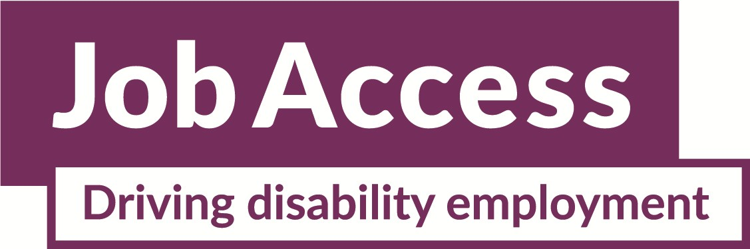

Employing people with disability
There are business benefits when you employ a person with disability— benefits beyond just filling a job. These benefits are supported by Australian and international studies. Employees with disability are:
- Reliable - people with disability take fewer days off, take less sick leave and have a higher retention rate than other workers.
- Productive - once in the right job, people with disability perform equally as well as other employees.
- Affordable - recruitment, insurance cover and compensation costs are lower. People with disability have fewer compensation incidents and accidents at work in comparison to other employees.
- Good for business - People with disability build strong relationships with customers, and boost staff morale and loyalty by helping create a diverse workforce. There are real cost savings through reduced turnover, recruitment and retraining costs. Employing people with disability contributes to the organisation’s overall diversity. It enhances the company’s image among its staff, customers and community with positive benefits to the employer brand. Being a disability friendly organisation is a good way to promote your business.

Managing access requirements
Your employee can choose if they want to share information about their access requirements. There is no legal obligation for them to share information about their disability unless it affects their ability to perform the inherent requirements of their job.
Information about an employee’s disability often involves sensitive personal details. If an employee shares information about their disability, you must consider providing reasonable adjustments to accommodate their work-related needs.

Workplace flexibility
Being flexible about work arrangements can help your organisation to attract and retain employees, including people with disability.
If you need to make workplace changes or buy special equipment for an employee with disability, your costs may be covered by the Employment Assistance Fund.

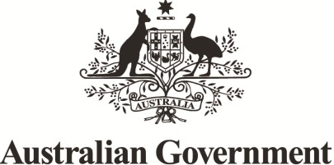
JobAccess is the national hub for workplace and employment information for people with disability, employers and service providers.

1800 464 800 www.jobaccess.gov.au

