Survey report

The impact of workplace adjustments, two years on.

October 2023

Acknowledgement of Country
We acknowledge the traditional custodians of Australia and the lands upon which we live and work and pay our respects to Elders past and present. We acknowledge the stories, traditions, and living cultures of Aboriginal and Torres Strait Islander peoples on this land.

Executive summary
The Australian Government’s JobAccess service provides expert advice, independent worksite assessments, recommendations and financial assistance for solutions to remove disability-specific barriers in the workplace by administering the Employment Assistance Fund (EAF).
A two-year follow up survey was sent to individuals who had previously received funding to gain insight into their current employment situation, their economic and social circumstances as well as their perspectives about the medium-term impact of the EAF program.
The survey findings outlined below show that:
- The vast majority of EAF recipients remain employed two years after the initial assistance was received, the majority with their original employer
- The majority of EAF recipients feel that their job is sustainable two years after the initial EAF assistance was received
- Work is perceived to add value to the lives of EAF recipients by providing a sense of purpose, financial security and social connectedness, as well as a sense of being valued and self-confidence
Overall, these findings provide evidence that the delivery of EAF funding and services through JobAccess has helped individuals with a variety of disabilities to maintain employment and improve productivity, giving rise to better quality of life for these individuals and their families, and also providing a positive economic impact to Australian society.
The survey findings also indicate that the program is likely to result in sustainable and longer-term benefits beyond those initially gained when assistance is first provided.
- 96% of respondents remain employed two years after receiving the EAF funding
- 94% of respondents said the equipment, modification or service received through the EAF improved their productivity at work
- 17%of respondents said they received a promotion in the two-year period
- 98%of respondents said that work adds value to their life
“JobAccess is essential, and if it did not exist, I would not be employable…Full time and job at level — can contribute to superannuation — can retire comfortably — and with less Government welfare support.”
EAF Recipient

Introduction
JobAccess is the national hub for disability employment, funded by the Australian Government and administered by the MedHealth Group on their behalf.
JobAccess assists in driving disability employment in Australia by helping people with disability get work, stay in work and progress in their careers, while also supporting employers to build their disability confidence and competence.
Since its inception in July 2006, JobAccess has helped over 452,000 people with disability, employers and service providers with advice and support and managed over 65,000 applications for workplace modifications.
JobAccess brings together several services into a single hub including the provision of information and advice as well as support and training to help remove disability specific barriers in the workplace and the coordination of assessments and funding of workplace modifications via the Employment Assistance Fund (EAF).
The EAF assists people with disability to improve their access to employment by reimbursing employers, Disability Employment Service Providers, individuals and self-employed people with disability the costs of modifying the workplace, adjusting existing workplace equipment, purchasing assistive technology or services that remove disability specific barriers in order for them to do their job.
To obtain a measure impact and satisfaction, a 13-week post-EAF support outcome survey is distributed on a weekly basis to employers and employees who have received assistance from EAF through JobAccess. The purpose of the survey is to evaluate EAF program satisfaction and acceptability and to assist with continuous improvement. In addition, the intent is to provide an indication of employees current (two-year post-EAF funding) employment-related, economic and social circumstances and their perspectives about the medium-term impact of the EAF funding. Where survey responses indicated that further engagement could be required, individuals were contacted by JobAccess to provide assistance and advice where necessary.

Survey cohort
A total of 116 recipients of the EAF funding initiative were surveyed from April — October 2021, 13 weeks after receiving their funding. Of those, a total of 80 employees initially responding to the 2021 survey indicated that they were happy to be recontacted. This sub-group were resurveyed by JobAccess in August 2023, approximately 2 years post-EAF funding.
The 2023 cohort (excluding n=36 who had requested not to be contacted following the first survey) included a total sample size of 48 survey respondents. Excluding those who were not approached, the n=48 reflected a response rate of 60%.
Table 1: Types of disability (number and %) represented in the 2021 and 2023 surveyed samples
Disability type | 2021 (n=80) | % of sample | 2023 (n=48) | % of sample
Blind / low vision | 22 | 27.5% | 16 | 33.3%
Dual sensory issues (Deaf / blind) | 1 | 1.3% | 0 | 0%
Deaf / hard of hearing | 19 | 23.8% | 11 | 22.9%
Physical disability | 20 | 25.0% | 9 | 18.8%
Spinal Cord Injury (SCI) | 6 | 7.5% | 4 | 8.3%
Cerebral Palsy (CP) | 3 | 3.8% | 1 | 2.1%
Neurological disorder | 5 | 6.3% | 3 | 6.3%
Acquired Brain Impairment (ABI) | 2 | 2.5% | 2 | 4.2%
Learning disorder | 1 | 1.3% | 1 | 2.1%
Other¹ | 1 | 1.3% | 1 | 2.1%
TOTAL | 80 | 100% | 48 | 100%

¹ This individual had multiple disabilities. Of note, there are several disability types that are eligible for EAF funding that are not represented within these cohorts, including but not limited to Down syndrome, epilepsy, mental health conditions, multiple sclerosis, autism spectrum disorders, intellectual disability and speech / verbal expression disabilities.
As seen in Table 1 above, the types of disabilities that were highly represented within the 2021 and 2023 EAF funding cohorts were those with a sensory impairment (hearing &/or vision related), and those with physical disabilities (general physical, SCI, CP). Those with neurological and learning disabilities comprised a small proportion of the samples.

Survey results
Where are the EAF recipients employed?
It was of interest to look at the industries that employed those who were recipients of EAF funding across the two cohorts (see Table 2). Of note, 46 of the 48 resurveyed in 2023 remained employed (96%) in 2023, with 41 of those (85%) remaining with their original employer.
Table 2: ANZSIC Industries represented in the 2021 and 2023 EAF funding cohorts surveyed
#2021 | Industry Groupings (ANZSIC) | # 2023
1 | Accommodation and Food Services | 1
4 | Administrative and Support Services | 1
3 | Agriculture, Forestry and Fishing | 3
2 | Arts and Recreation Services | 2
0 | Construction | 0
15 | Education and Training | 10
2 | Electricity, Gas, Water and Waste Services | 1
2 | Financial and Insurance Services | 1
28 | Health Care and Social Assistance | 14
5 | Information Media and Telecommunications | 2
1 | Manufacturing | 0
1 | Mining | 0
3 | Other Services | 2
3 | Professional, Scientific and Technical Services | 2
8 | Public Administration and Safety | 4
0 | Rental, Hiring and Real Estate Services | 0
1 | Retail Trade | 2
0 | Transport, Postal and Warehousing | 1
1 | Wholesale Trade | 1
0 | Unemployed | 1
80 |  | 48
Most commonly represented ANZSIC industries across the EAF recipients were Health Care and Social Assistance (including disability services) with approximately 30% employed within this sector, then Education with around 20%, and Public Administration and Safety (general government departments not represented by health or education) with around 10%.
Five respondents were self-employed representing a variety of industries. Also, of note (and not shown separately in the statistics above), approximately a third of the EAF recipients (2021 and 2023) were employed by Government (local, state or federal) organisations, mostly within the health and education sectors.

Employment status and sustainability
The 2023 follow-up survey results indicate a high level of sustained employment for EAF recipients and continuation of employment with the same employer. More specifically, findings (see Table 3) showed that:
- 46 of the 48 resurveyed remained employed (96%) two years following the EAF funding was received
- One of 48 had moved into retirement
- 41 of those still employed (89%) remained with the original employer
- The number of hours employed per week remained the same for the vast majority (80.4%)

Table 3: Item responses pertaining to employment status and sustainability in 2023
Survey Item | 2023 responses | Percentage  of n=48 (%) | Comparison with  2021 (if relevant /  data available)
Currently still employed? | Yes n=46  No n=2 | 95.8%  4.2% | N/A
If yes, with original employer? | Yes n=41  No n=5 | 89.1%  10.9% | N/A
Feel that job is sustainable?  (i.e. likelihood working in 12 months) | Yes n=41  No n=5 | 89.1%  10.9% | Not asked in 2021
Change in number of hours? | No n=37  ↑ n=3  ↓ n=6 | 80.4%  6.5%  13.0% | 87.0%  13.0%  0%
Change in rate of pay? | No n=18  ↑ n=28  ↓ n=0 | 39.1%  60.9%  0% | 87.0%  13.0%  0%
Have you had a promotion? | Yes n=8  No n=38 | 17.4%  82.6% | Not asked in 2021
The vast majority of the follow-up sample (almost 90%) also reported feeling that their job was sustainable and that they would be working in 12 months’ time. Only a minority reported a reduction in the number of hours employed since 2021 (13%), with a small proportion showing an increase in the number of hours (6.5%) (Table 3). Almost 61% reported an increase in the rate of pay within that two-year period, and around 17% also reported having received a promotion.
Of direct interest to the sustainability and value of the EAF assistance program and evidence of the positive impact to employers and employees, the program recipients were asked whether the equipment, modification or service received had helped them to be more productive at work.
Responses to this question were overwhelmingly positive (93.8% yes), with 62.5% reporting substantial improvements in productivity. Of note, these data measured ‘two years on’ are more positive than the results received when asked the same question immediately after they had received their EAF funding when 81.3% provided a positive response, and of those a lower percentage indicating that the improvement was ‘substantial’ in nature.
Table 4: Item responses pertaining to employment satisfaction in 2023 (new items)
Survey Item | Response | Percentage (%)
Generally happy with employment? | Yes n=44  No n=2 | 95.7%  4.3%
Happy with hours that you are working?  Prefer to remain same, increased or decreased hours?² | Same n=37  ↑ n=2  ↓ n=7 | 80.4%  4.3%  15.2%
Work adds value to my life. | Yes n=47  No n=1 | 97.9%  2.1%
² Responses to these 2 items excluded those who were currently not employed.
The vast majority of the 2023 cohort, recipients of the EAF initiative two years prior, reported that they are generally happy with their employment (95.7%, see Table 4), with the majority also indicating that they are happy with the hours that they are currently working (80.4%). Approximately 15% indicated that they would prefer fewer hours, and 4% more hours than they currently have per week.
Note that the two individuals reporting that they are not generally happy with their employment (other than the two who were not currently employed), also reported that they felt that their job was not sustainable within the next 12 months, with reasons indicating that their employers may not be as supportive as they could be of their disability and/or that the workload / role may be negatively impacting their wellbeing over the long term.
Also of note is that 14 of the initial sample of survey respondents have re-engaged with JobAccess within the intervening years. This re-engagement to provide additional assistance and support can be provided where a barrier in the workplace remains due to for example a deterioration in function, change of duties or workplace etc.

Program perceptions and value of work for EAF recipients
As a high-level representation of program satisfaction, it is of value to note the consistently high Net Promotor Score (NPS) score of 75 that was received for both the initial (n=80 and follow-up (n=48) samples.
The entire cohort that responded to the 2023 survey with the exception of one individual (97.9% of the sample) reported that work adds value to their life. This indicates that the program is being delivered to people who can, and do, see the value that work brings to their lives, and also that the program is likely to result in sustainable and longer-term benefits than those seen in the first two years since the assistance was provided.
When respondents were asked to indicate which areas of their lives are improved by working (choice from a drop-down list of evidence-informed options), the majority of individuals selected at least 3-4 of the seven options provided.
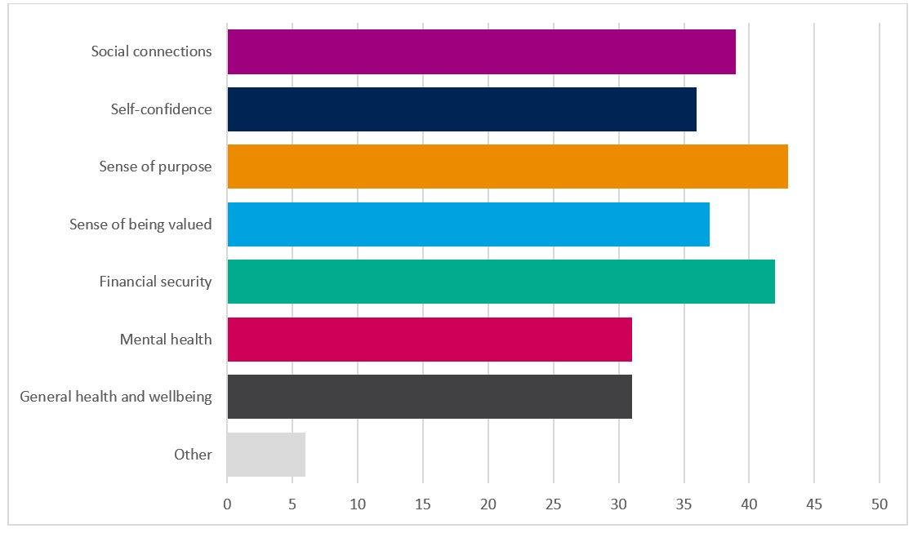
Figure 1: The areas of life improved by working identified by the 2023 cohort of EAF recipients (n=48)
As Figure 1 shows, there were a range of areas identified by the EAF recipients at the two-year follow-up point as having benefited from working. Those most commonly identified included a sense of purpose, financial security and social connectedness, with a sense of being valued and self-confidence also commonly selected.
Qualitative results were also analysed by identifying the emerging themes for two open-ended survey questions.
The first open-ended question asked what they would like to change, given the opportunity, about their employment. There were three general themes identified that are briefly outlined below:
Work and workplace requirements
- Adjustment of working hours, and hours onsite to better suit individual circumstances
- Have set workstations (not hot desking) with accessibility settings that are not changed
- More (equal) accessibility to trialing different roles within the workplace
- Ensuring that approved equipment funding is implemented ASAP
Work environment / culture
- Have more staff trained in disability awareness, and to act as advocates when required, e.g., improved understanding and consideration of ‘appropriate’ noise levels in office for those who are hard of hearing; assistance with updating work adjustments; improve general attitudes (less stigma) towards co-workers with disabilities
- Employment strategy or guidelines to assist with ongoing needs for all employees with a disability for example a Diversity, Equity and Inclusion plan
Additional reasonable adjustments required
- Additional assistance with IT and other areas, where required, due to the disability3
- Additional ergonomic equipment to make it easier to work more efficiently, and
- Follow-ups to check whether there are any changes or adjustments required, e.g., ergonomic equipment, different types of equipment in home vs office environment
³ Note that IT support after equipment and associated support has been funded is the responsibility of the employer
The final question asked for general feedback about the program and any additional comments. The feedback was overwhelmingly positive, as is demonstrated by the three selected quotes below.
Through these comments, the positive intrinsic value of work was reiterated, and recipients communicated how grateful they were for the equipment that has made their work easier, more enjoyable and through which they have become more productive.
Also communicated was how grateful they were for the friendly and efficient support provided by JobAccess, the service that administers the Employment Assistance Fund.
“The assistance has made me a lot more productive. Work is so important for self-worth looking forward and not thinking as much about what I used to be. Thanks so much to JobAccess.”
EAF Recipient - Assisted since 2019
“The assistance continues to prove to be great value. The equipment provided is used at varying degrees as sight is variable but knowing I have this assistance is so valuable.”
EAF Recipient - Assisted since 2021
“JobAccess is essential and if it did not exist I would not be employable… Fulltime and job at level – can contribute to superannuation – can retire comfortably – and with less Govt welfare support. Dragon voice recognition software is fantastic and enables me to stay in the workforce – makes a huge difference – can’t work without it.”
EAF Recipient - Assisted since 2016
There were also notably a few (not many) suggested improvements for the EAF program provided by the EAF recipients surveyed, including to ensure that:
- the equipment comes with guidelines to assist with set-up4
- increased advertising so more key stakeholders know about the service
⁴ Instructions are provided as standard with options to trouble shoot with the supplier and employer supports (ie. IT services) as well as re-engage with JobAccess.

Conclusion and implications
These follow-up survey findings provide clear evidence of the value of the Employment Assistance Fund and service provision through JobAccess in the context of maintaining employment, improving productivity, and boosting quality of life and financial stability for individuals with disability, and their families. There is also an unmeasured positive economic impact for Australian society in sustaining employment for people with disabilities.
In terms of limitations, the surveyed cohorts are not entirely representative of the broader range of disabilities eligible for EAF funding, which also includes (but not represented in the sample) Down syndrome, epilepsy, mental health conditions, multiple sclerosis, neurodiverse disorders, intellectual disability and speech / verbal expression disabilities. As such, the follow-up cohort will be expanded in the coming months to enable the collection of results from a more representative and larger sample of EAF recipients.

About JobAccess

JobAccess is a free Australian Government service that offers expert advice, practical resources and good practice strategies — on matters ranging from workplace adjustments to building employer confidence — to drive disability employment.
This easy-to-use, one-stop service provides holistic advice, navigational support and tailored solutions for all people with disability, employers and service providers.
JobAccess services are designed to remove barriers to sustainable employment for people with disability. These services are delivered by a team of allied health professionals and disability employment experts that include people with lived experience and carers who listen, advise and support by keeping the individual and employer in focus.
JobAccess is recognised internationally for its innovative approach to disability employment. The United Nations Public Service Award and Essl Foundation’s Zero Project initiative have recognised JobAccess for improving the delivery of services and innovative policies, respectively.

