Disability Employment National Panel of Assessors – Your Service Guarantee
The Australian Government’s Disability Employment National Panel of Assessors provides assessment services to enhance employment participation and support for people with disability. National Panel of Assessors will work cooperatively with clients including people with disability, employers and Disability Employment Service providers. We will:
- explain clearly the purpose of the assessment services, what assessment services you will receive, what we will do for you, and what you have to do
- deliver a professional, confidential and timely service
- treat you fairly and with respect
- ensure the information we provide is current and accurate
- work continually to improve our services
- produce an independent assessment report taking into consideration information obtained during the conduct of the assessment.

What can I expect?
We will work with you to conduct the following assessments:
- Ongoing Support Assessment for Participants of the Disability Employment Services program
- Supported Wage System Assessment
- Workplace Modifications Assessment.
We will contact you prior to conducting the assessment to:
- explain the purpose and procedure for the assessment
- make arrangements to meet with you to conduct the assessment
- agree any special requirements for the assessment, including access to the worksite, WHS requirements and interpreters
- answer any questions about the assessment
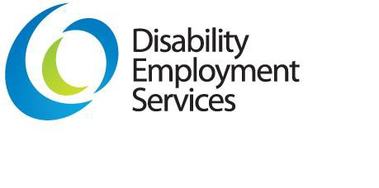
- obtain information that may help us to understand your employment requirements and prepare for the assessment
- provide our contact details to you and be available to answer questions relating to each assessment that we conduct.
When we conduct the assessment, we will:
- describe the steps involved in the assessment
- discuss the relevant work tasks, and any issues that impact on performing those tasks
- behave in a manner that is not obstructive or stressful
- respect you and the work environment
- record appropriate information that relates to the assessment and that will assist us in preparing the assessment report
- ensure that your privacy and dignity are maintained.

What are my responsibilities?
If for any reason you are not able to keep an appointment, you should advise us as soon as you can and we will reschedule the appointment.
To ensure that we provide an effective and efficient assessment service to you, you need to provide current and accurate information to us.
If we visit your worksite to conduct assessment services, the employer should advise us of any special access and WHS requirements.

What happens to what I tell you?
The information we collect from you is only used to complete the assessment.
We will keep all information that you provide in accordance with the Privacy Act 1988 (Cth).
If you ask, we will usually be able to show you the information we hold about you. If you have any concerns about the way in which information about you is being managed, you can discuss your concerns with us.
More information about the Privacy Act 1988 (Cth) can be obtained from the Office of the Federal Privacy Commissioner's website at http://www.privacy.gov.au

What can I do if I’m not happy with the assessment service?
If you are not satisfied with the way we conducted the assessment service, you should first try to talk to us. We will provide a feedback process that is fair and we will try to resolve your concerns.

If you can’t do this, or you are still not happy, you can get assistance from one of the following relevant numbers:

Ongoing Support Assessments – contact the Australian Government’s Customer Service Line on 1800 805 260

Supported Wage System Assessments – contact the Assessment Team on 1800 065 123

Workplace Modifications Assessments – contact the JobAccess service on 1800 464 800

